Development Application Assessment Report
Officer: B Pogson  Peer Review: S Boyton | Date of Assessment: 22/11/24  Date of Peer Review: 25/11/24

Application Details
Application No. | 8/2023/502/1
Property Address | 109-129 Kelso Street SINGLETON 2330
Lot and DP | Lot: 4 DP: 1119857
Parcel No. | 24541
Description of development | Educational Establishment – Alterations and Additions
Applicant | Christian Education Ministries Ltd
Date lodged | Friday, 03 November 2023
Owners Consent | Provided
Capital Investment Value | $15,159,142
Zoning | PART RU1 Primary Production / PART SP2 Infrastructure

Detailed Description of the Development

Development Application No. 8.2023.502.1 seeks approval for an Educational Establishment.

“The proposed development will comprise the construction of a new two (2) storey school building, delivered in three (3) stages). The building will cater for an increase in student population of approximately 300 students (700 total student population) and will provide additional general learning areas, staff and W/C facilities in the first stage of construction. During the second stage of construction, additional general learning areas would be provided and the final stage of construction will include the construction of additional car parking.

The construction would also upgrade vehicle access arrangements and will require the removal of 20 trees.

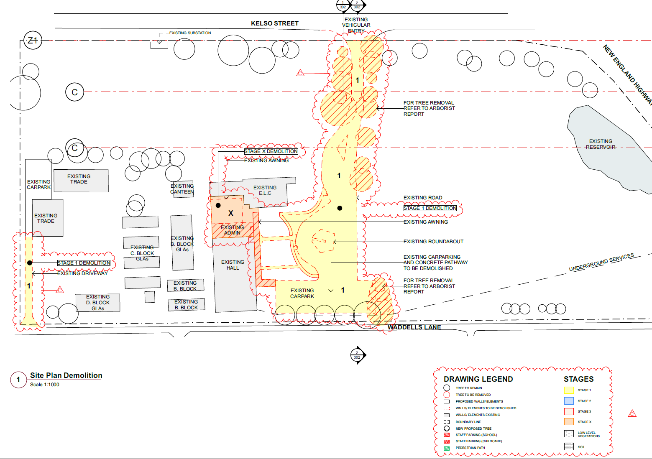
Figure 1: Extract of existing Site Plan, with items for demolition shown in red (source: CEM).

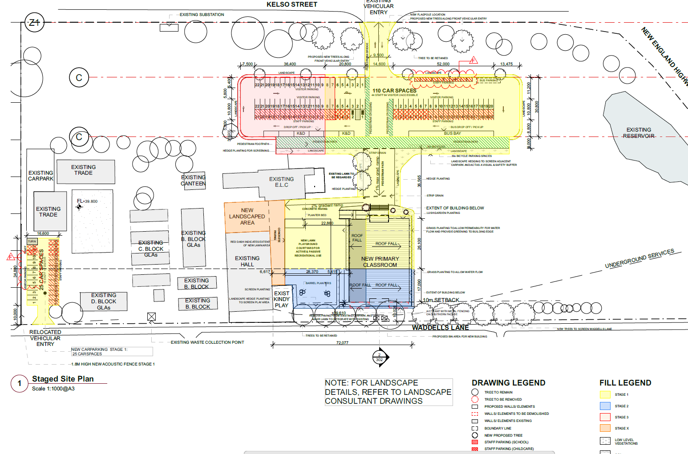

Figure 2: Extract of staged Site Plan (source: CEM).
Figure 3: Extract of building perspective of the northern building elevation (Source: CEM).

Demolition and Site Preparation
The proposed works will involve demolition works to facilitate the new building and car parking, including:
- Removal of twenty (20) planted species trees comprising:
  - 16 with moderate retention values
  - 4 with very low retention value
- Demolition of existing on-site carparking, internal driveway and vehicle access points
- Demolition of existing administrative building
- Minor cut and fill for site levelling

Physical Works
The proposed works include:
- Construction of new 2-storey school building (over two stages)
- Ground floor
- Seven (7) General Learning Areas (GLAs)
- One (1) Specialty Room
- Flexible Learning Area
- Student amenities
- Reception and administration area comprising
- Reception
- Meeting room
- Kitchenette
- Amenities
- Three (3) office spaces
- Circulation space
- Two (2) stairwells to the First Floor
- One (1) stairwell off the rear exit
- Lift shaft for accessible access

- First Floor
- Seven (7) General Learning Areas (GLAs)
- Library
- Flexible Learning Area
- Student amenities
- Circulation space
- Two (2) stairwells to Ground Floor
- Lift shaft for accessible access

- New courtyard and landscaped area between the existing hall and the new school building
- Construction of a new northern carpark area (over two stages) comprising:
- 108 car parking spaces (inclusive of 2 x accessible spaces)
- Kiss and dop area
- Bus stop
- Pedestrian crossing and footpath
- New southern car parking area comprising
- Relocation of vehicle access
- 25 carpark spaces
- Installation of a 1.8 metre acoustic fence

Staging
The construction and occupation of the proposed development is intended to be undertaken over three (3) stages and will reflect the progressive increase in student enrolments.

Stage 1
Comprises the construction of the northern section of the school building, including seven (7) GLAs, library, administration and reception area, circulation space, staircase, and lift access, as well as amenities. Stage 1 will also include first phase of construction for northern carpark area (accessed via Kelso Street) and the construction of the southern carpark area (accessed via Waddells Lane)

Stage 2
Will comprise the construction of the southern section of the school building with seven (7) GLAs, Specialty Room, circulation space and rear exit.

Stage 3
Will comprise the construction of the second phase of the northern carpark area

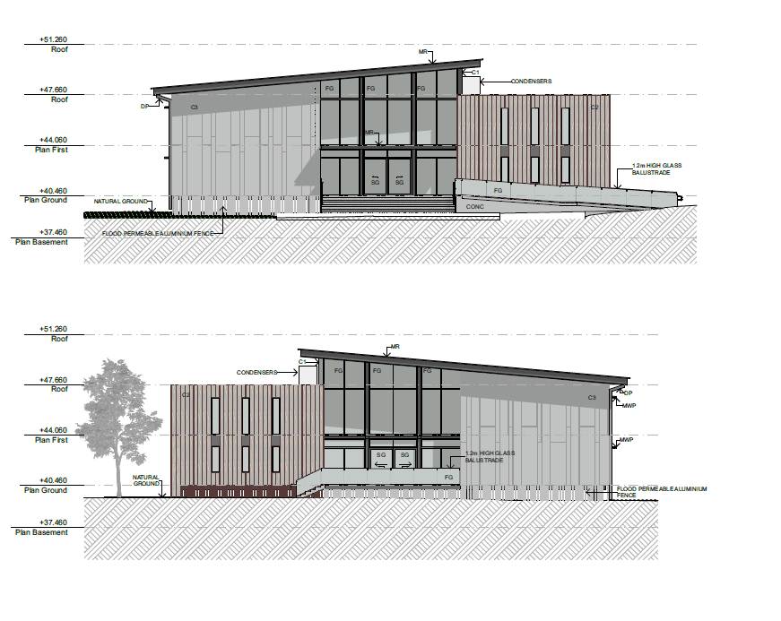
Figure 4: Extract of building elevation (Source: CEM).

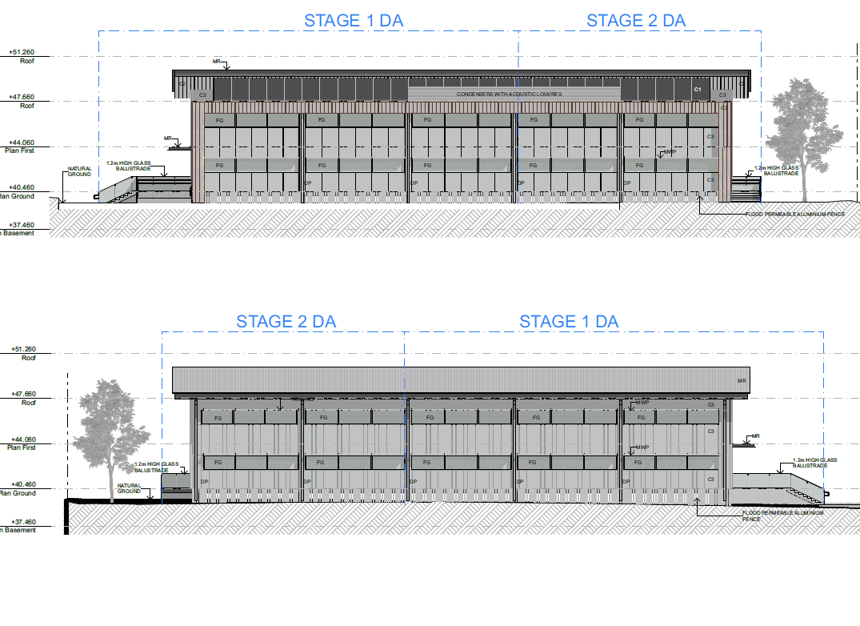
Figure 5: Extract of building elevation (Source: CEM).

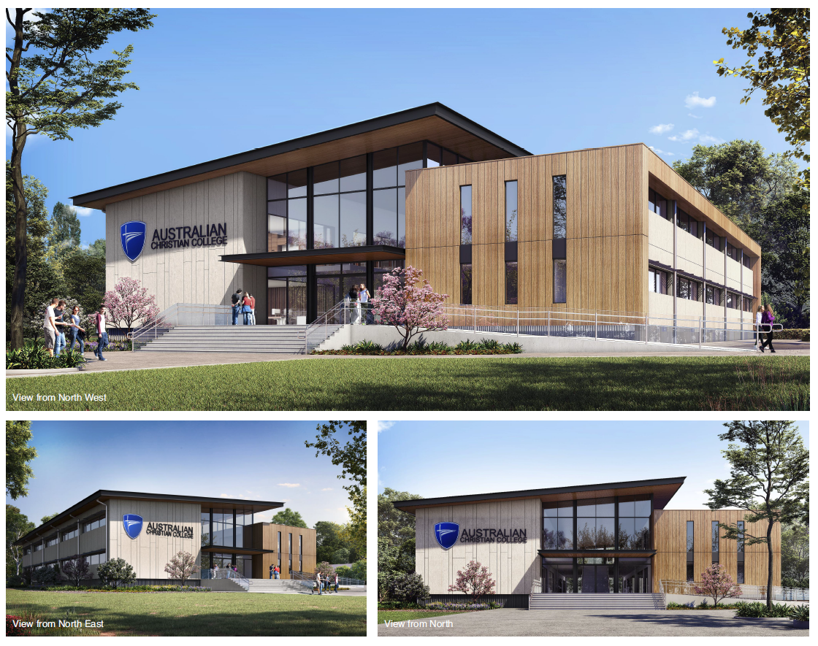

Figure 6: Extract of 3D rendered imagery (Source: CEM).

Applicant Statement Of Environnmental Effects (AD23/56872)
Applicant follow documentation responding to RFIs (AD24/61172)

Site Constraints

The subject site is affected by the following constraint(s):

- Flooding, Opposite a Heritage item

These constraints are not considered to cause the site to be unsuitable for the proposed development. Appropriate conditions of consent are recommended to mitigate the potential impacts in relation to flooding, heritage and have been addressed in this report

Site History

The subject site has historically been used for an Education Establishment

The following applications have been lodged over the subject land:
- 8.2012.431.1 – Advertising sign - – no reference to student numbers
- 8.2009.334.1 – Awning - – no reference to student numbers
- 8.2007.28.1 & 2 - Alterations/Additons to Existing School - – no reference to student numbers
- 8.2004.150.1 – additions to College – no reference to student numbers
- 8.2002.632.1 – Childcare – 59 children

The site has been used as an Educational Establishment since the late 1980s. The records for the original approval cannot be located and there is no reference to an approved number of students except for the Childcare of 59 children.

The applicant has identified the current school polulation number as of 2024 to be 378 students and 37 staff. The applicant has used this as a basline in lieu of any known approved student numbers (see AD24/103957 & AD24/103960).

88B Instrument and Deposited Plan

There are no matters identified on the 88B instrument or deposited plan that would impact upon the proposed development.

Site Inspection

A site inspection was not undertaken.

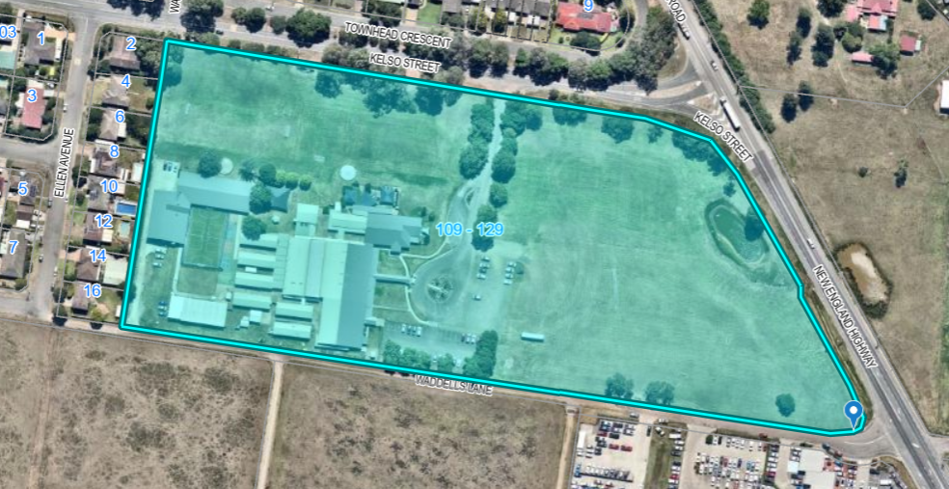
Figure 7 – Aerial imagery

Environmental Planning and Assessment Act 1979

Classification of development | Yes | No
Is the development proposal Local Development? | ☒ | ☐
Is notification necessary? | ☒ | ☐
Have all adjoining and affected owners been notified (two week period)? | ☒ | ☐
Is the development proposal Advertised Development? | ☐ | ☒
Have adjoining and affected properties been notified? | ☐ | ☒
Has an advertisement been placed in local newspaper? | ☐ | ☒
Is the development proposal Nominated Integrated Development or captured under Threatened Species Act? | ☐ | ☒
Has the development been advertised for 30 days | ☐ | ☐
Is the development proposal of Regional Significance? | ☒ | ☐
Is the development proposal State Significant Development? | ☐ | ☒

Designated Development | Yes | No
Is the development proposal Designated Development? | ☐ | ☒
Is the proposal for alterations or additions to development (whether existing or approved) that fits the definition of designated development? | ☐ | ☒
If yes above, will the alterations or additions significantly increase the environmental impacts of the total development (that is the development together with the additions or alterations) compared with the existing or approved development? | ☐ | ☒
Has an Environmental Impact Statement been submitted? | ☐ | ☒
Has the application been notified for a period of 30 days? | ☐ | ☒
Have adjoining and affected properties been notified? | ☐ | ☒
Has a notice been displayed on site? | ☐ | ☒
Have copies of plans been placed at Council, Department and Consent Authorities Office (i.e. if JRPP). | ☐ | ☒
Has an advertisement been placed in local newspaper on at least two occasions? | ☐ | ☒

Integrated Development

In accordance with Section 4.46 of the Environmental Planning and Assessment Act, 1979 the proposed development does not require approval from any external agency.

Internal Referral Assessment

Engineering Referral Response (AD23/59632)

The application is considered to be satisfactory in relation to engineering matters subject to conditions being imposed on the notice of determination.

The existing school campus is wholly contained within Lot 4 in Deposited Plan (DP) 1119857 and supports the operation of a centre-based childcare facility. The site is generally rectangular in shape with an irregular eastern boundary that abuts the approximately northwest-to-southeast alignment of the New England Highway. The campus has an overall site area of approximately 5.578 hectares and is relatively flat, with a gentle slope towards the southwest boundary.

The primary road access provided from Kelso Street, approximately 115m west of the intersection of the New England Highway and bisects the campus, runs approximately north to south. A secondary informal vehicle access is provided from the southern boundary at Waddells Lane approximately 400 metres from the intersection to the New England Highway and provides access to a parking area adjacent to the western Lot boundary.

The built form of the campus is situated in the slightly elevated southwestern portion of the site and in addition to the centre-based childcare centre, comprises buildings for K-12 education including administration, library, staff, general learning areas (GLAs) and outdoor play areas. The middle portion of the site comprises vehicle access and parking with the remaining areas of the site comprising an open grassed area that facilitates overland flow and interallotment drainage.

Intermittent tree cover from a mix of planted species is provided along the northern boundary and adjacent to the existing vehicle access and parking area. A dam and associated stormwater culvert are located adjacent to the eastern boundary and are connected to the oppositely located agricultural property.

The site is zoned RU1 Primary Production and SP2 Infrastructure under the Singleton Local Environmental Plan 2013 (the SLEP). The proposed development would be undertaken in the portion of the site zoned RU1 and educational establishments are prohibited in RU1 zoned land. However, the proposal is permissible pursuant to Division 4.11 of the Environmental Planning and Assessment Act 1979 as an existing use and Section 3.36(3) of State Environmental Planning Policy (transport and Infrastructure) 2021 as development within the boundaries of an existing school.

The proposal comprises the demolition of existing structures, the staged construction of a new classroom building, and the construction of two (2) car parking areas and associated works to deliver a capacity at the school site for 700 students.

Additional Information Received 30/05/2024

The applicant submitted the following amendments following the Regional Planning Panel briefing:

The proposed amendments comprise:

- The submission of a draft Operational Management Plan which includes the operational details of the existing and proposed uses including:
- General operating periods
- Operational parameters
- Parking and access
- Special events
- Emergency management

- The submission of a Flood Emergency Response Plan (FERP) that has been prepared following a review of BMT’s submitted flood study and clarifies:
- Flood warning procedures
- Evacuation strategy
- Implementation of the FERP will reduce flood risk at the school

- The provision of a School Transport Plan and a revised Transport Impact Assessment that:
- Identifies mode share for students
- Provides appropriate transport initiatives
- Confirms the level of Service (LoS) for affected intersections
- Demonstrates that the school expansion won’t impact traffic conditions, prior to the completion of the Singelton Bypass
- Provides policies and management measures that reduce traffic generation

- The provision of Landscape Plans which:
- Include additional tree plantings
- Provide additional landscape embellishments

- Additional and updated Civil Engineering Plans to include existing and proposed RLs for the carpark and adjoining landscape areas

- Updates to the Waste Management Plan which document the waste management arrangements on and off-site and identifies that waste collection is:
- Serviced on a ‘as needs basis by a waste collection provider’
- Undertaken after 7am and accessed via Waddells Lane

- Updates to the Architectural Plans including:
- Retention of three (3) additional trees at the site’s southern boundary, which were originally proposed for removal
- Inclusion of landscape embellishments and additional trees to reflect details set out in the landscape plan
- Inclusion of five (5) additional car park spaces at Stage 1 to accommodate adjusted student numbers
- Inclusion of 20 x bicycle parking spaces
- Inclusion of additional landscaping at stage 2
- Identification of waste collection point.

Road (eg Traffic volume)
Kelso Street at the development site has a sealed pavement approximately 8m wide. Kelso Street would be considered an urban collector street under Council’s road hierarchy with a maximum traffic volume of 6000 vehicles per day.

The traffic impact assessment submitted states that the future year base scenario with the completion of the Singleton bypass will improve the traffic conditions of the intersection from LoS F/E to C/B with a noticeable reduction in expected queues and that the introduction of the bypass leads to the acceptable performance of the intersection in the future year without any additional upgrades necessary. The assessment concluded that there are no changes in LoS in both peak periods and only minor increases in delay when development traffic is introduced according to their modelling.

Council’s Traffic Engineering Officer completed a Traffic Referral with the following advice:

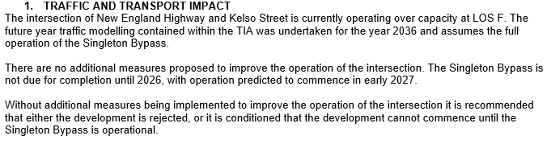

It is recommended that the advice from the Traffic Engineering Officer be considered.

Additional Information Received 30/05/2024

A School Transport Plan (STP) and revised Transport Impact Assessment (TIA) have been prepared by SCT Consulting.

The STP provides polices and procedure for the interim scenario between development consent and the opening of the Singleton Bypass in 2026. The STP confirms that during this period, with the use of staggered bell times and the operation of the school’s OOSH, ACC singleton could accommodate an additional 113 students before any additional car trips would be generated in the surrounding network.

The TIA has been amended in response to the above and recommends that the proposed development include a condition of consent that:

- Require the STP to be implemented as an interim measure to manage traffic impacts, prior to the opening of the Singleton Bypass in 2026.
- Until the Singleton Bypass is opened, limit the school’s student population to 491 students.

Access
Access to the site will remain from Kelso Street to the main car park. The secondary access will also remain from Waddells Lane to a separate smaller car park.

The applicant is proposing to upgrade both accesses as part of stage 1 of the works with the Kelso Street access increased to 9.5m in width. The turning swept paths provided show that the access road will be adequate for busses with a wheelbase length of 8.20m.

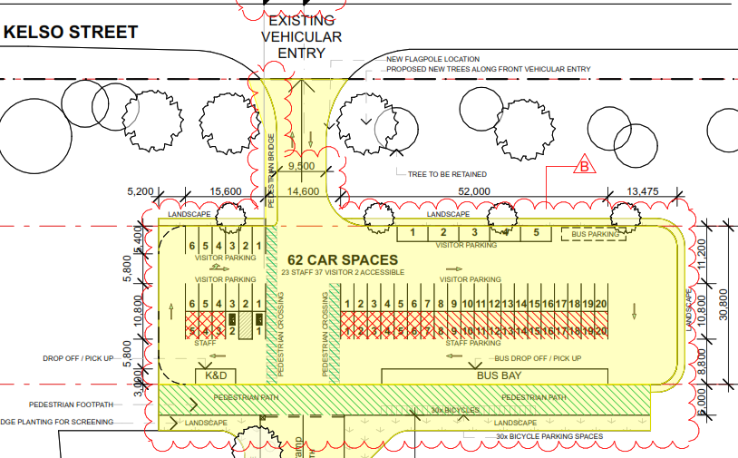

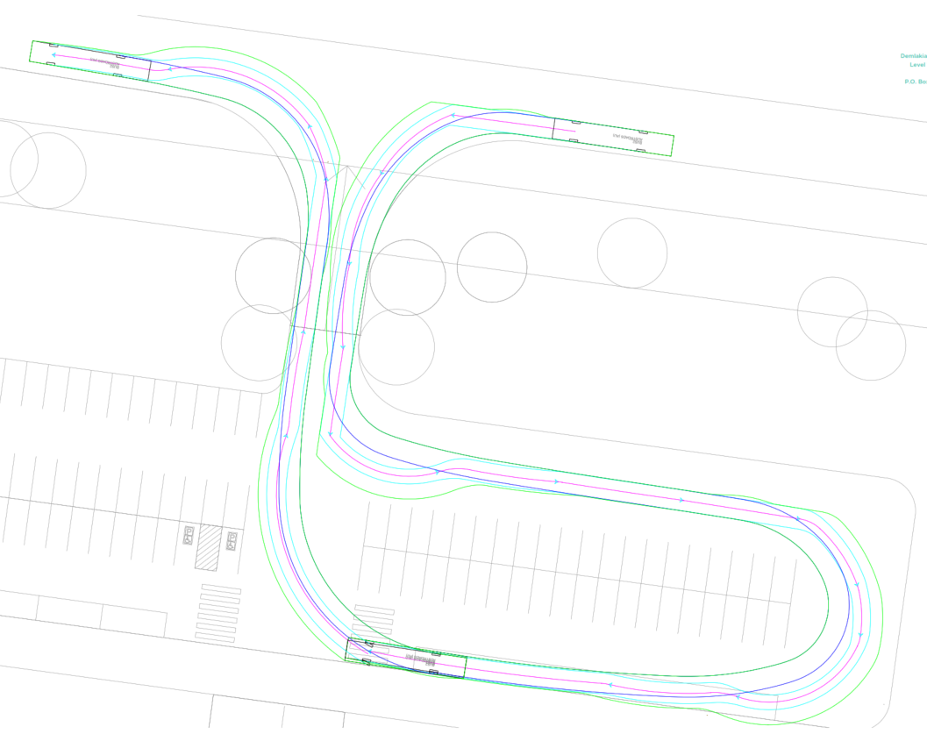

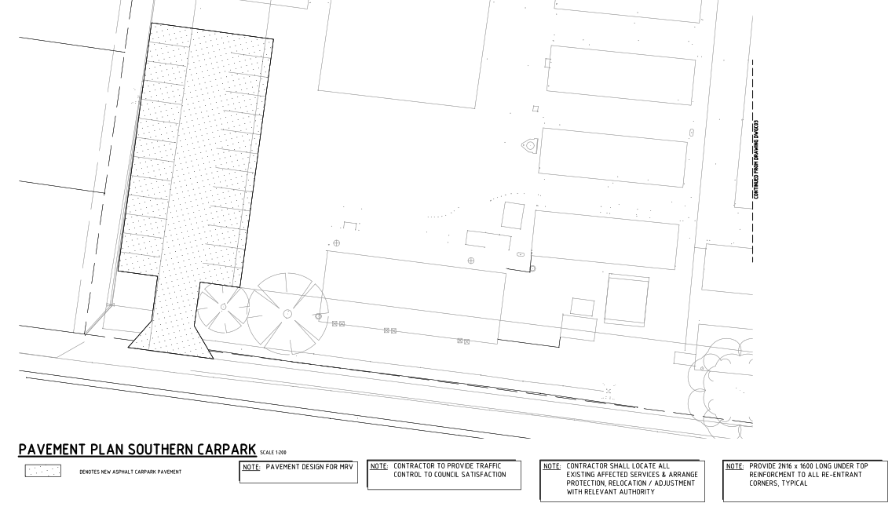

Flooding (eg flood prone, detention)
The site is mapped within the Flood Planning area under the LEP flood planning map however, there is no minimum floor height restriction for this site. The Singleton Flood Risk Management Study and Plan indicate that the proposed parking area and building will be outside the H5 and H6 hazard categories. The parking area will be predominantly within a H4 hazard category whilst the building will be within a H2 hazard category. See below:

Singleton Flood Risk Management Study and Plan – Hazard Categories
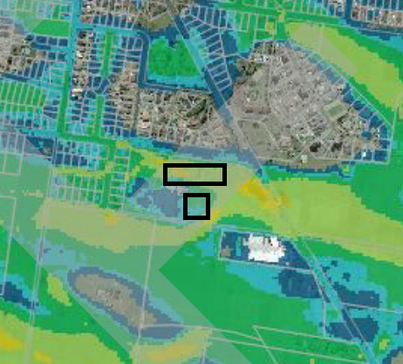

The BMT Flood Impact Assessment (FIA) dated 17 October 2023, has also modelled the flood risk to the site. The FIA has identified that, during phases one and two of the car park and new building’s construction and in the final stage three development Scenario, suitable flood mitigation measures have been provided. As a result of these measures, the proposed development would not result in adverse flood impacts beyond the boundaries of the Site.

With regards to stages 1 and 2, the FIA identifies that the carpark adjacent to Kelso Street is not susceptible to flooding at the 1% Annual Exceedance Probability (AEP) level but identifies that the southern carpark is subject to inundation at the 1% AEP level. The FIA identifies that the level of inundation would create an H1 hazard classification and would be generally safe for vehicles, people and buildings.

Likewise, the FIA identifies that the under-croft area of the new building would experience an H1 hazard at the 1% AEP level. The report also outlines that the driveway access connecting the carpark and Kelso Street is predicted to have flood immunity during all local flood events modelled.

During the stage 3 development scenario, the FIA identifies that during floods less than the 1% AEP event, flood inundation is primarily attributed to overland flow from the local catchments, with peak flood depth within the site ranging between 0.5m and 0.7m during the 1% AEP event.

During local flooding, the FIA outlines that open spaces would range between a H2 (unsafe for small vehicles) to a H3 (unsafe for vehicles and children) but would increase to H4 (Unsafe for people and vehicles) during mainstream flooding from the Hunter River in a 1% AEP event. The FIA identifies that the under-croft to the new building would experience H3 and H4 classification from mainstream flooding but concludes that with the proposed new building elevated above the 1% AEP event with 500mm freeboard suitable flood mitigation has been provided.

Accordingly, the FIA concludes that the staged development of the site is not predicted to cause adverse flood impacts beyond the boundaries of the school.

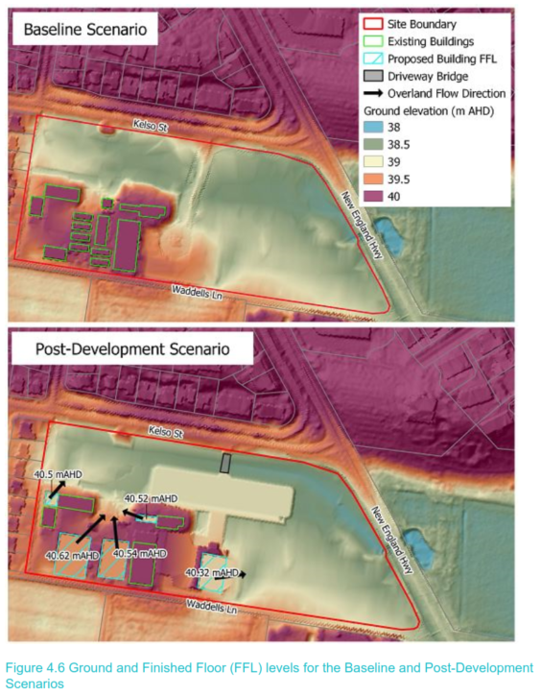

Local Models:
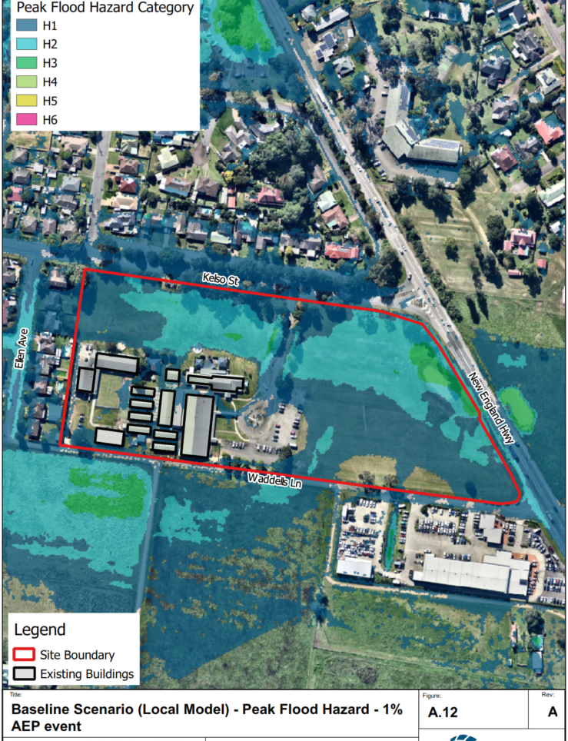

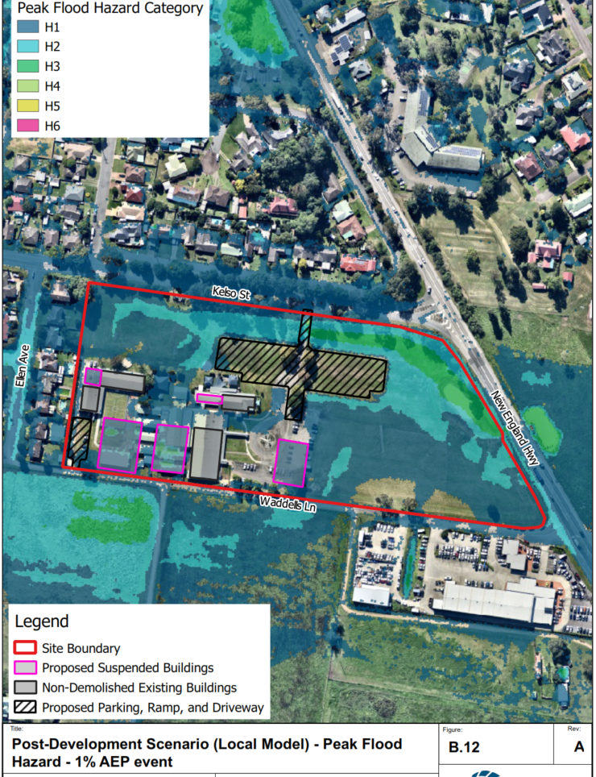

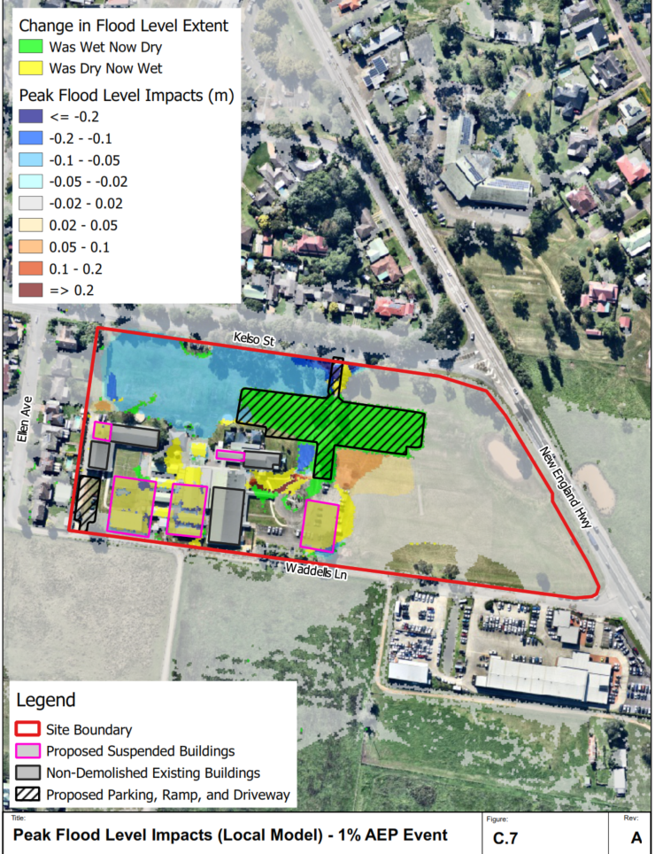

Mainstream Models:

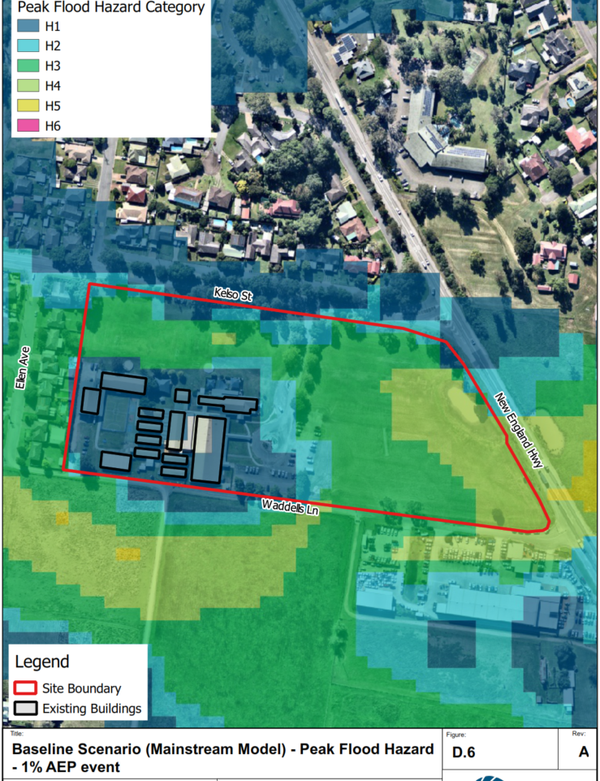

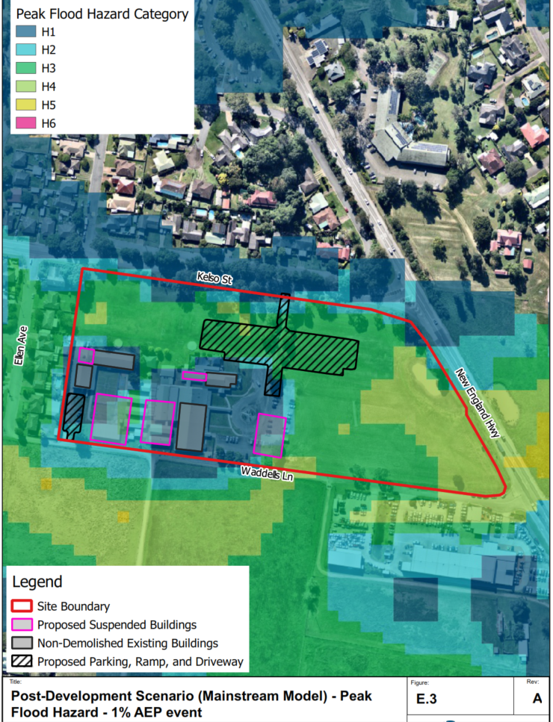

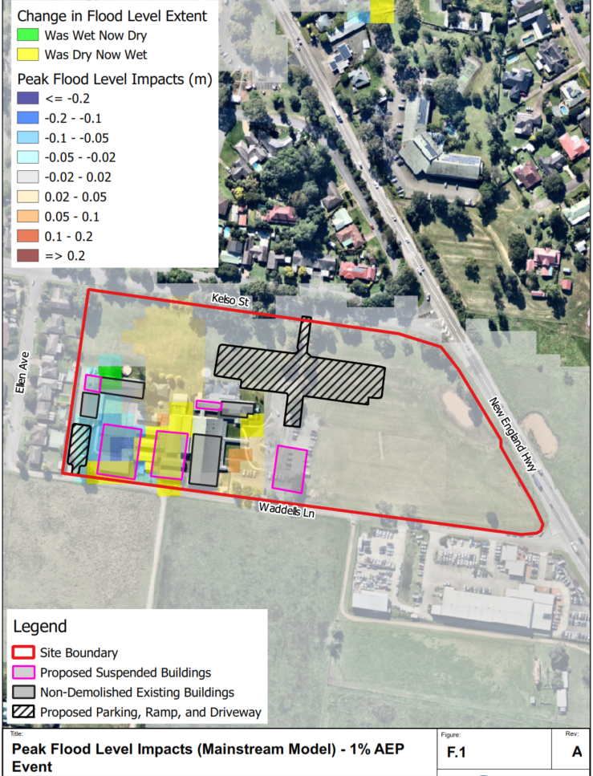

The Flood Impact Assessments provided illustrate that the development will not cause adverse flood impacts beyond the boundaries of the school and conclude that with the proposed new building elevated above the 1% AEP event with a 500mm freeboard, suitable flood mitigation has been provided. This is acceptable.

Additional Information Received 05/11/2024

A Flood Emergency Response Plan (FERP) has been developed by Martens, incorporating the flood studies prepared by BMT. The FERP outlines flood warning procedures designed to effectively reduce flood risk at the existing campus.

It is recommended that the Martens & Associates Flood Emergency Response Plan (FERP) be implemented to ensure that, in the event of a flood, risks to personal safety and the environment are effectively managed.

Development engineering advice regarding item (viii) of the NSW Planning Panel Deferral:

According to the NSW SES (2018) Singleton Flood Emergency Sub Plan, there is an estimated 10-hour window to evacuate the Singleton township. The SES Plan further notes that it takes an additional 9.75 to 18.5 hours for flood levels to rise from the minor flood level to the point where the Queen Street evacuation route becomes impassable. This provides an overall timeframe of approximately 16 to 24 hours to evacuate the township.

As the available warning time (16-24 hours) exceeds the time required to evacuate (10 hours), there is ample time to fully evacuate the Singleton area prior to the cutoff of the evacuation route.

The proposed development will increase the school population from 378 to 536 (including both staff and students). Assuming a conservative estimate of one additional vehicle per person and a travel rate of 600 vehicles per hour, the time to evacuate the additional school population is estimated at approximately 16 minutes. This would increase the total evacuation time to 10.25 hours. However, this still falls within the available warning time of 16-24 hours, ensuring that there is sufficient time to evacuate the Singleton area before the evacuation route is cut off, even with the additional traffic from the proposed development.

In Stage 3 of the proposal, the total population is expected to rise to 700 students and 88 staff, representing an increase of 410 people. This would increase the total evacuation time to approximately 10.7 hours, still within the available warning time, ensuring that Stage 3 of the development can also be fully evacuated prior to the cutoff of the evacuation route.

Development engineering advice regarding item (ix) of the NSW Planning Panel Deferral:

It appears that the correct FFL levels are now shown in the Flood Emergency Response Plan (FERP).

Development engineering assessment against the provisions of Clause 5.21 of the SLEP:

- The Flood Impact Assessment (October 2023) conducted by BMT concludes that the proposed new suspended building will be positioned above the 1% AEP flood extents with a 500 mm freeboard. Offsite afflux is projected to remain under 20 mm during the 1% AEP flood event, which is considered negligible. As such, the development will not increase the risk to people or property, and is compatible with the site's flood function and behavior.
- According to the BMT report, the modelling results show that the proposed development does not materially affect local flood characteristics during the 1% AEP event. Overall, the flooding conditions are expected to remain largely unchanged from existing conditions, and the flood impacts of the development are deemed acceptable.
- The SES Timeline Evacuation Model (TEM) confirms that the proposed evacuation route can accommodate both existing and anticipated local traffic.

Drainage

Internal site drainage consisting of a pit and pipe system with associated overflow routes is proposed. The network has been designed to allow for sheet flow up to 18 mm deep to traverse the site and enter the OSD basin.

On-site detention (OSD) system as an above-ground basin in the car park is to be provided to limit the runoff from the site to its pre-developed state.

One SPEL Hydro channel and Stormsack inserts are to be provided throughout the network before entering the above-ground OSD basin.

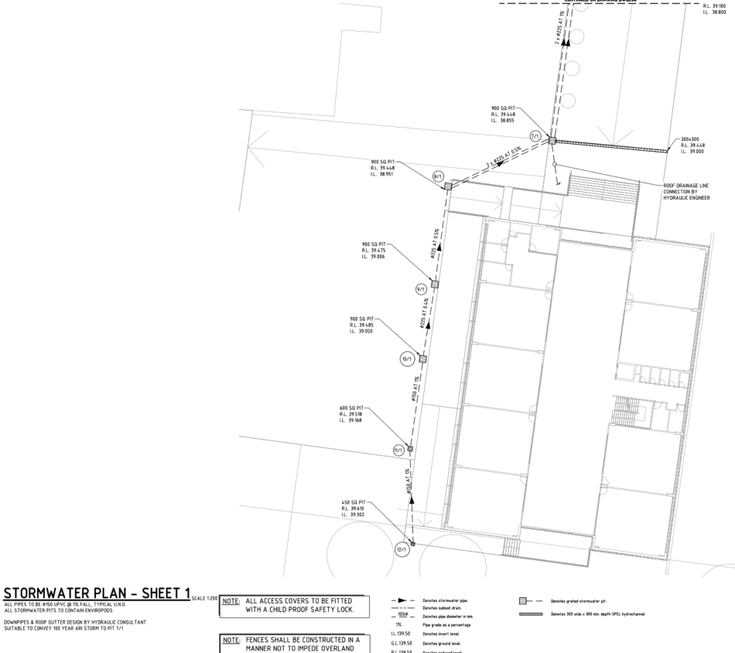

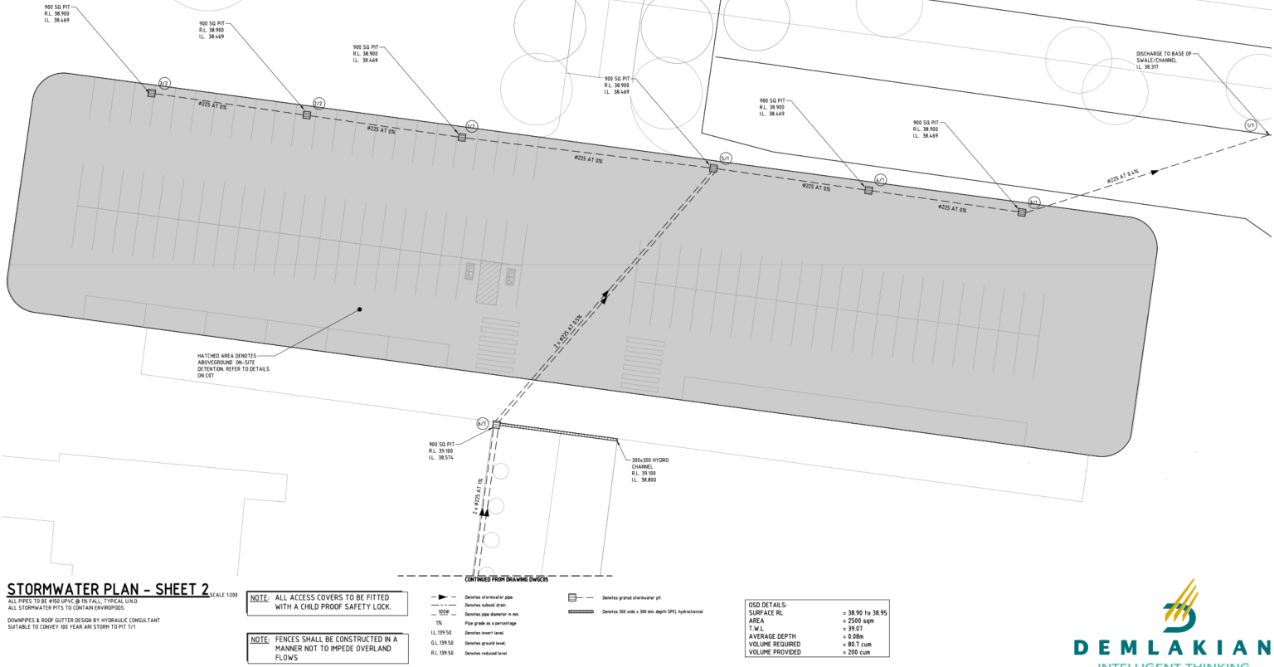

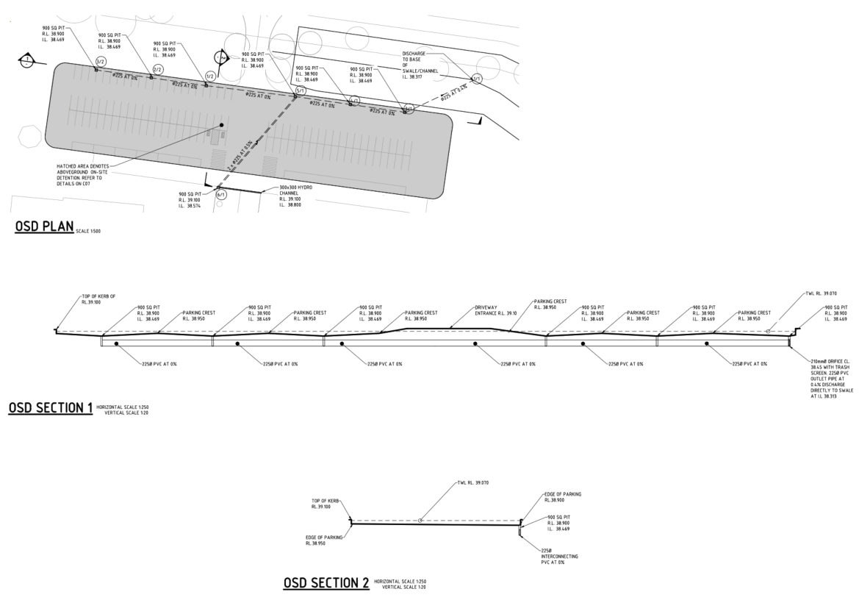

Additional Information Received 05/11/2024

Provisions have been made to manage the anticipated stormwater flow from west to east across the site. This includes the construction of a "bridge" between the northern boundary and the proposed car park, allowing stormwater to flow beneath the access road, in alignment with the existing overland stormwater flow path.

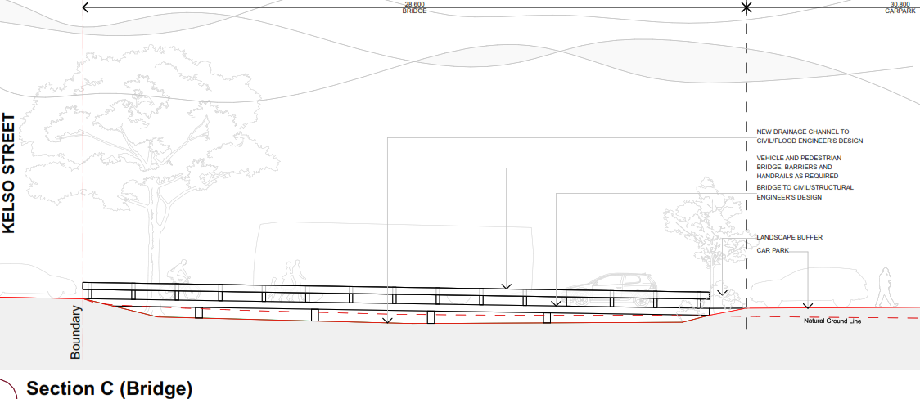

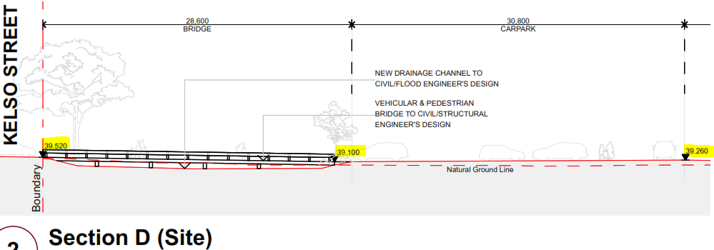

Ecology Referral Response (AD23/59637)

The application is considered to be satisfactory in relation to Ecology matters subject to conditions being imposed on the notice of determination.

“The site is not mapped as containing biodiversity values under the Biodiversity Conservation Act 2016 and has been mapped as containing low biodiversity values under the Singleton high biodiversity value mapping project.

The proposal will require the removal of 20 trees, consisting of horticultural plantings, including Jacaranda mimosifolia, Cinnamomum camphora and Plantanus x acerifolia. No impacts to native vegetation will occur as a result of the proposal. Additionally, no hollows or significant trees will be impacted.

The application is supported. No significant impacts to any threatened ecological communities, flora and fauna and their habitats will occur as a result of the proposal. Standard conditions relating to tree protection, along with those conditions identified below are to be included as part of any consent. Additionally, the management actions identified in the Arborist Report for Tree 1 and Tree 2 are to be implemented during works.”

Building Referral Response (AD23/59630)

The application is considered to be satisfactory in relation to Building matters subject to conditions being imposed on the notice of determination.

“Class 9b,
Rise in Stories: Two,
Type of Construction: Type B.”

Environmental Compliance Referral Response (AD23/59631)

The application is considered to be satisfactory in relation to Environmental Compliance matters subject to conditions being imposed on the notice of determination.

“An acoustic report has been provided which has recommended suitable noise attenuation measures (1.8m fence in the SW corner of the premises). Suitable waste management and demolition information have also been provided.”

Traffic Referral Response (AD23/59633)

The application is considered to be satisfactory in relation to Traffic matters subject to conditions being imposed on the notice of determination.

- TRAFFIC AND TRANSPORT IMPACT
The intersection of New England Highway and Kelso Street is currently operating over capacity at LOS F. The future year traffic modelling contained within the TIA was undertaken for the year 2036 and assumes the full operation of the Singleton Bypass.

There are no additional measures proposed to improve the operation of the intersection. The Singleton Bypass is not due for completion until 2026, with operation predicted to commence in early 2027.

Without additional measures being implemented to improve the operation of the intersection it is recommended that either the development is rejected, or it is conditioned that the development cannot commence until the Singleton Bypass is operational.

- PARKING
The Singleton DCP specifies the following parking requirements:

- Childcare Centre - 1 space per staff member + 1 space per 4 enrolled children.
Development (no change to existing) = 55 students and 15 staff (14 and 15 spaces)

- School - 0.5 space per staff member + 1 space per 10 students
Development Stage 2 - 700 students and 88 staff = 70 + 44 spaces

Total required spaces = 143 spaces

The TIA states "A total of 82 spaces and 130 spaces are provided in the master plan for Stage 1 and Stage 2, respectively, which satisfies the DCP requirement."

The parking spaces provided is a shortfall of 13 spaces based on the requirements of the DCP.

The TIA mentions different drop off/pick up periods between childcare and the school, which results in a shared parking area, but this is not expanded on sufficiently to justify the shortfall.

- CYCLE PARKING
Agreed that the number of cycle parking spaces required by the DCP of 0.75 per student spaces is excessive - this would result in 525 cycle parking spaces. Confirmation required as to the planned number of cycle parking spaces to be provided.

Update 11/6/2024

It is noted that:

The school expansion will now be delivered in 2 stages, stage 1 & 2 expanding student numbers from 378 to 491 students and stage 3 to the final total of 700 students.

The School Travel Plan will implement staggered bell times and OOSH to mitigate the traffic impacts during stage 1 & 2. This is considered to be an acceptable approach to manage the traffic impact associated with the development during this period.

The Singleton Bypass, once operational, will improve the LoS of the New England Highway/Kelso Street intersection from a LoS E to a LoS B in peak times. It is agreed that following completion of the Bypass that the LoS at the intersection will remain acceptable in both peak times without any additional upgrades to the intersection necessary.

It is agreed that the Traffic Impact Assessment, in combination with the School Travel Plan, adequately shows that that the traffic and transportation impacts associated with the proposed development will be able to be accommodated by the existing and planned road network.

Update 7/11/2024
Items requested to be address by NSW Gov Planning Panel:

(iii) Details of and clear delineation of drop-off/pick-up, bus parking, staff, student, and visitor parking, and pedestrian paths.

(iv) A Traffic and Access Operational Management Plan that addresses the functional requirements of all uses and how drop-off/pick-up will be managed across the site.

- Shortfall in parking and use of shared parking strategy still not justified sufficiently according to DCP. DCP states:
(5) Despite subclauses 3 and 4, development consent may be granted to development that provides a lesser number of onsite car parking spaces where the consent authority is satisfied that it is appropriate in the circumstances of the case because:
(a) there is a historic deficiency in car parking associated with the site, or
(b) the development is of a minor nature and would not create a demand for more than one additional car parking space, or
(c) there are no reasonable opportunities to provide parking onsite and there is sufficient public parking available in close proximity to the development site.

Applicant needs to explain how reduction in parking spaces from DCP requirements meets subclause 5 above. It appears that staggered drop off and pick up times in the Traffic Impact Assessment address the shortfall (ie excluding Childcare and Tafe visitor parking from total), however the DCP requirement above still needs to be addressed. Number of staff in operational plan of management for ACC is stated as 40 and 60 for stage 1-2 and 3 respectively where it is 45 and 88 in Traffic Impact Assessment, need to address this inconsistency.

- Bus parking and queuing:
Based on vehicle tracking paths provided in engineering plans, when more than 2 school buses are on site access and egress on western side of carpark will be affected. There is potential for buses queuing to block passenger vehicles from egress which could have a flow on effect of backing up both buses and passenger vehicles onto Kelso Street.

Clashing between queuing buses and passenger vehicles utilising carpark needs to be addressed by applicant.

- Pedestrian Paths:
Pedestrian paths are shown as connecting from Kelso across to path on south of carpark. Engineering plans only show pedestrian crossings from south of carpark to first row of parking. Bus tracking path appears to clash with intended pedestrian path shown in updated architectural plans.

Applicant needs to provide more detail of pedestrian paths and its interaction with vehicle manoeuvres.

- Bicycle Parking:
As per previous referral, agree that 0.75 parks per student (525 bicycle spaces) is excessive. Unsure how a reasonable amount would be determined. Traffic impact assessment states current active transport share of 3% (walking and cycling) resulting in a need for 20 bicycle parking spaces.

Possible method for determining need:
TfNSW Active Transport Strategy states that 15% and 14% of primary and secondary school students travel to school via active transport. Assume even split between cycles and other modes (walking, scooter etc) gives a need of 7.25% or 50 bicycle parking spaces for 700 students.

Update 22/11/24

Agree that applicant has adequately addressed points raised above through amended Operational Plan of Management and Masterplan received on 22/11/2024

Water and Sewer Referral Response (AD23/59668)

The application is considered to be satisfactory in relation to Water and Sewer matters subject to conditions being imposed on the notice of determination.

Liquid Trade Waste Referral Response (AD23/59669)

The application is considered to be satisfactory in relation to Liquid Trade Waste matters subject to conditions being imposed on the notice of determination.

Requested clarification that the sinks in GLAs on the ground floor will be used for wash-up after craft activities. This was confirmed.

“A new Application to Discharge Liquid Trade Waste is required for this proposal, which will address the required provision of plaster traps for these sinks.”. This is to be a condition of consent

Heritage Referral Response (23/74685)

The application is considered to be satisfactory in relation to Heritage matters.

“The proposal is only considered for its potential impact to Local Heritage Items, which the Heritage Impact Assessment has assessed at nil. Importantly, there will be no physical impacts upon the three heritage items nearby, and there are no detrimental visual impacts on the heritage items. There are no heritage constraints relating to this project therefore.”

External Referral Assessment

The Development Application was referred to Transport for NSW (TfNSW) on 08 November 2023 for comment in accordance with Section 3.58 of the State Environmental Planning Policy (Transport and Infrastructure) 2021. See RFI 24/64222.

All items identified by TfNSW have been addressed and the applicant has responded to the RFI’s relating to the issues raised. (AD24/61172)

Traffic assessment has been updated and a School Travel Plan has been created and supported by Councils Traffic Engineers.

Other

Having regard for Section 1.7 of the Environmental Planning and Assessment Act 1979, and subject to the provisions of Part 7 of the Biodiversity Conservation Act 2016 consideration must be given to whether development or activity that is “likely to significantly affect threatened species” as defined by section 7.2 of the Biodiversity Conservation Act 2016.

Additionally, subject to the Part 7A of the Fisheries Management Act 1994 consideration must be given to the provisions of Division 12, in particular section 221ZV as to whether the proposal is likely to significantly affect threatened species, population or ecological community.

The application does not propose to removal of any native vegetation and is will not have any impact upon the life cycle of the any species at risk of extinction or threatened/endangered species or their habitat. The proposed development is not considered to be a threatening process.

Section 4.14 – Bushfire Prone Land | Applicable
 | Y | ☐ | N | ☒

Planning Assessment

In determining a Development Application, the consent authority is to take into consideration the following matters as detailed in Section 4.15(1) of the Environmental Planning and Assessment Act, 1979 as follows:

(a)(i) the provisions of any environmental planning instrument (EPI)

State Environmental Planning Policies

State Environmental Planning Policy (Planning Systems) 2021 (PS SEPP)
Part 2.4 Regional significant development and Schedule 6 identifies the proposed development as being considered regionally significant due to a community facility exceeding $5 million in Capital Investment Value.

The determining authoritiy is the Hunter and Central Coast Regional Planning Panel.

The Panel members have conducted individual site inspections and conducted a preliminary briefing on 31/01/2024.

The panel made the following comments:
. 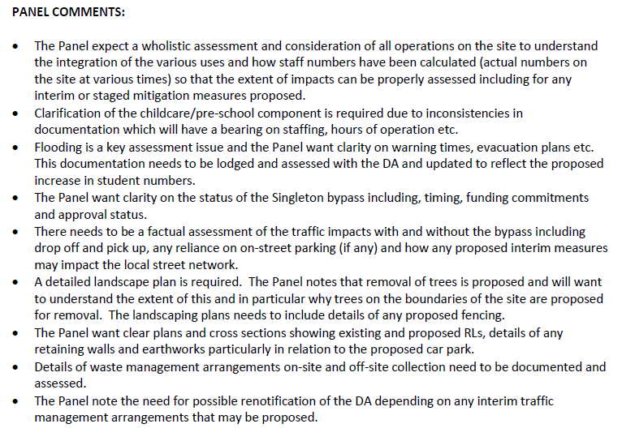

The applicant responded to Panels comments (AD24/61172)

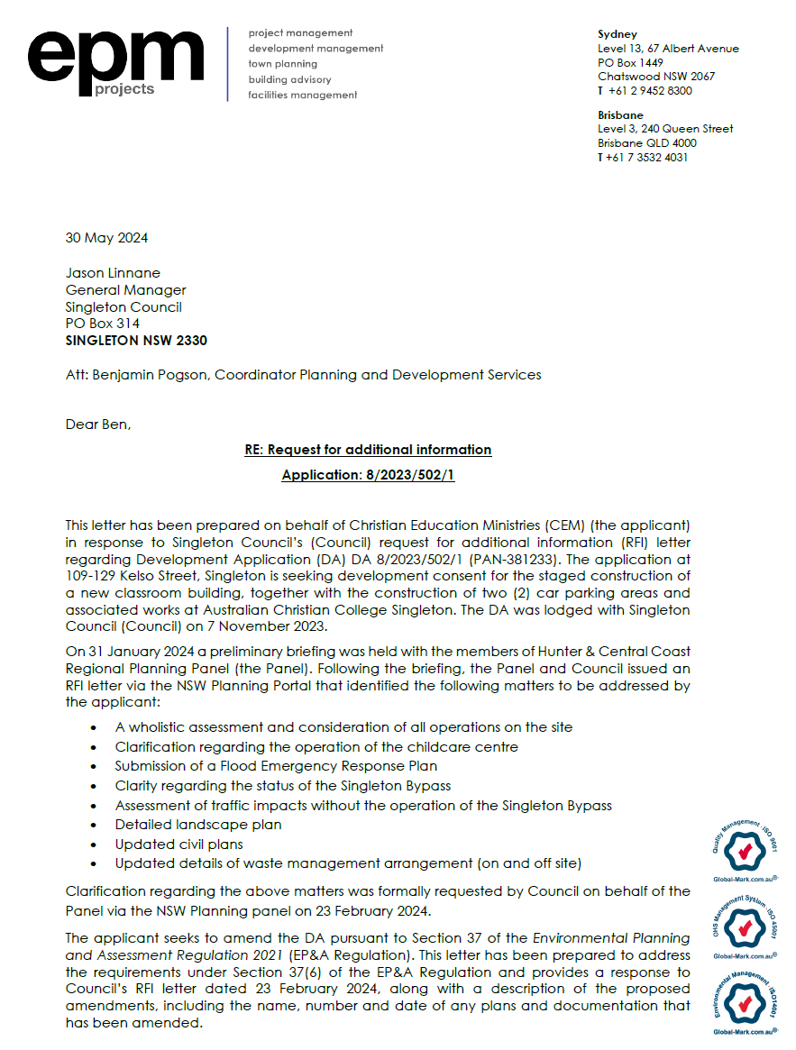

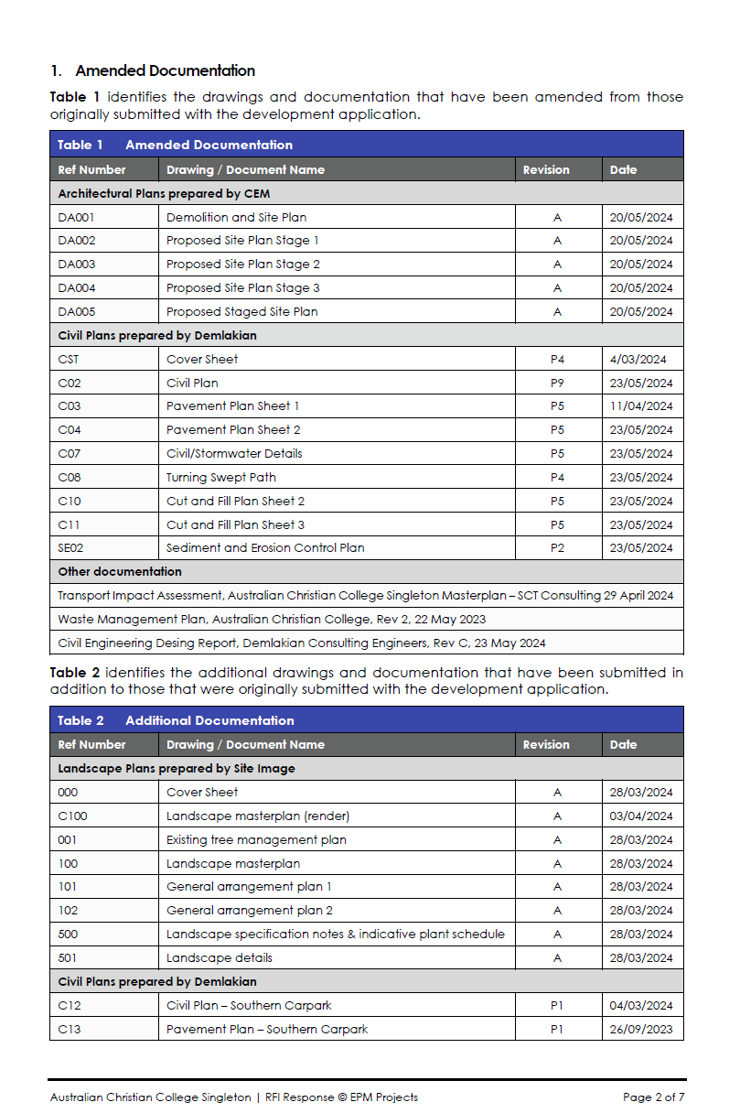

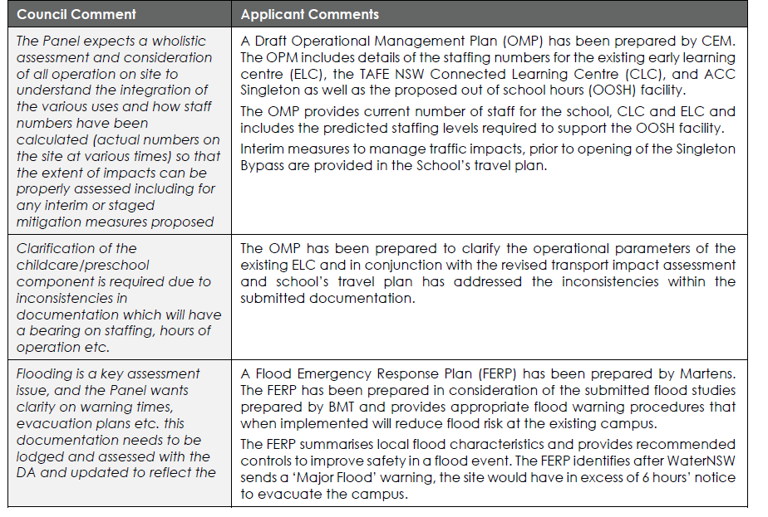
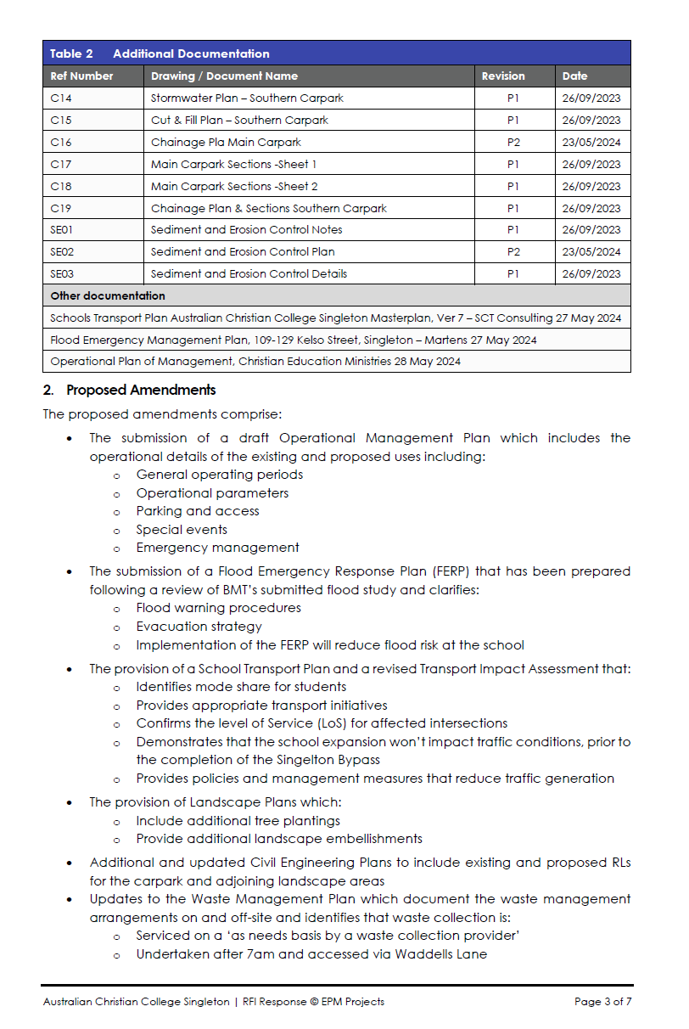
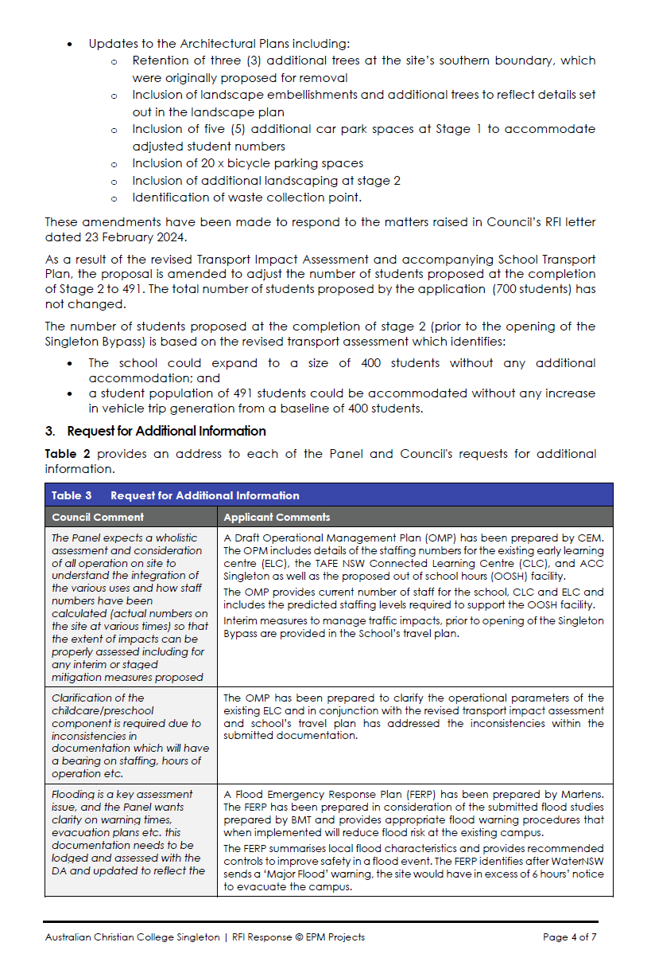
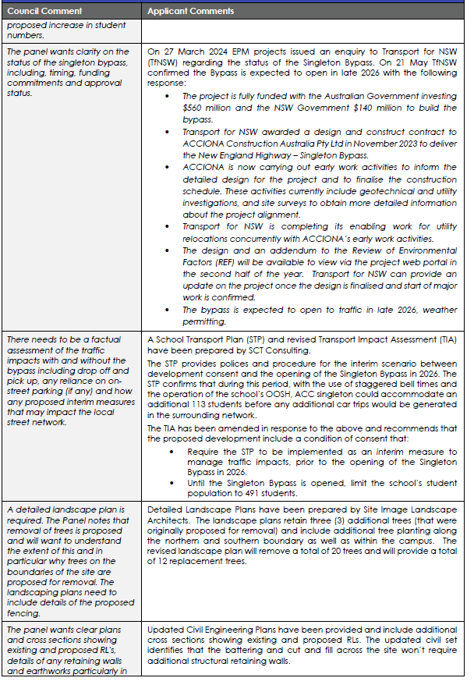
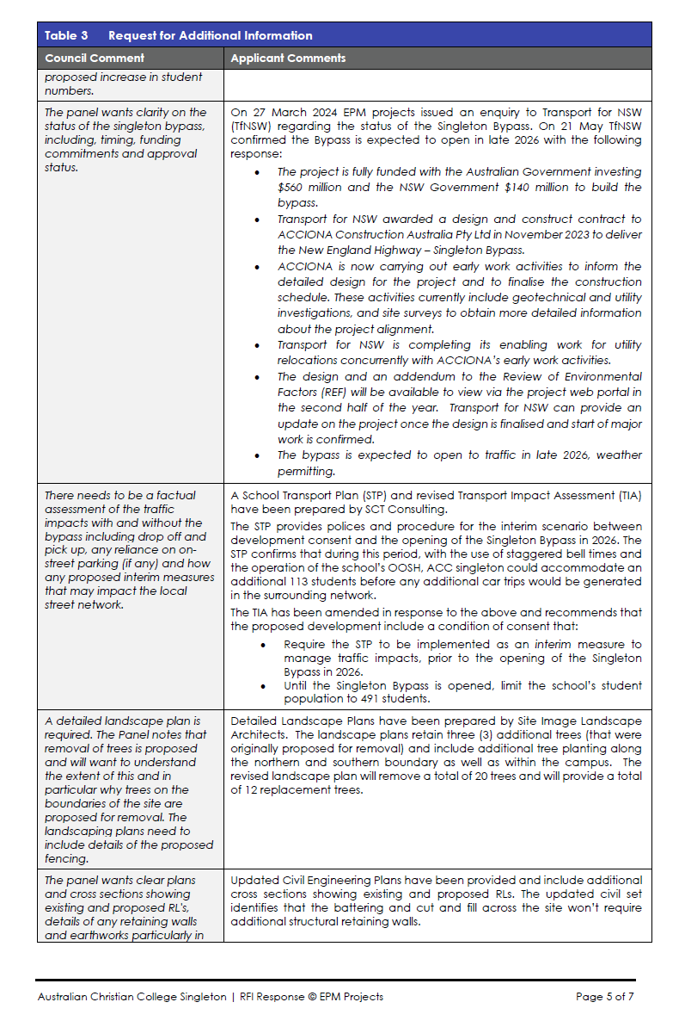
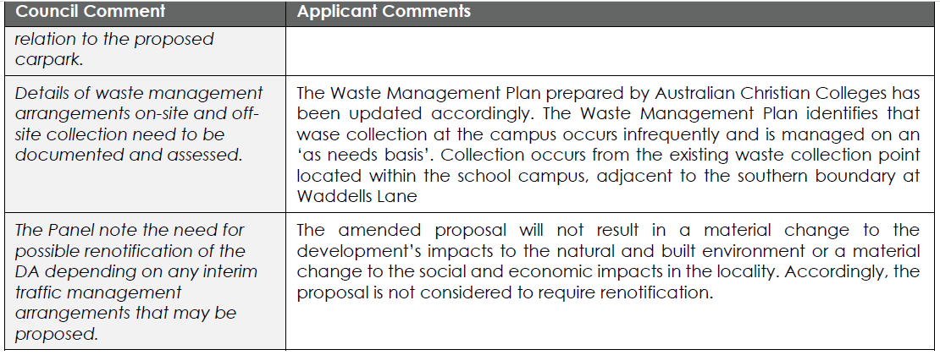

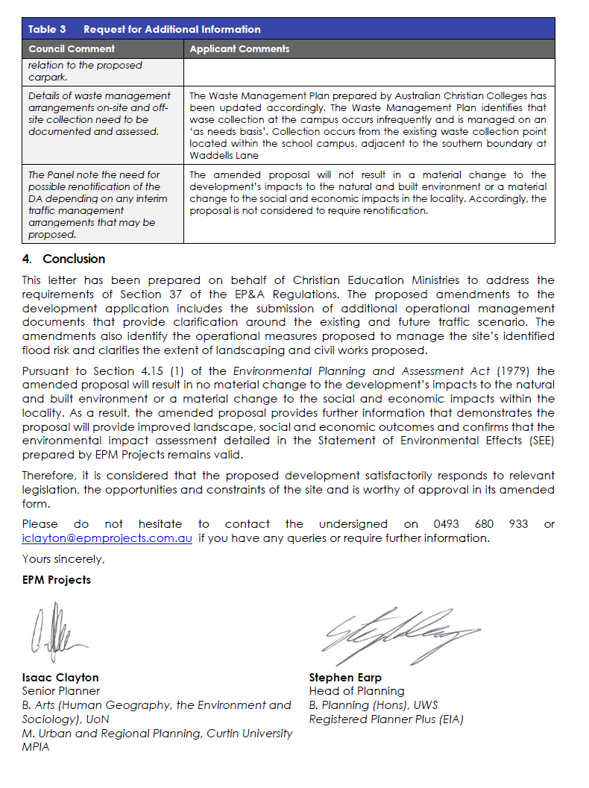

The application was re-referred to the Development Engineer and Traffic Engineer for comment and both engineers found this satificatory.

The Planning Panel was was provided the Planners Assessment Report and draft conditions for a determination on the 01/10/2024. The Panel deferred the matter and supplied a record on the 08/10/2024 of the items to be addressed prior to determination. (23/78056)

Subsequent discussions with the applicant led to the supply of additional information to Council on the 05/11/2024 and on the Planning Portal on 11/11/2024.

The applicant summary of the items to be addressed by the Panel can be seen below. (AD24/103960)

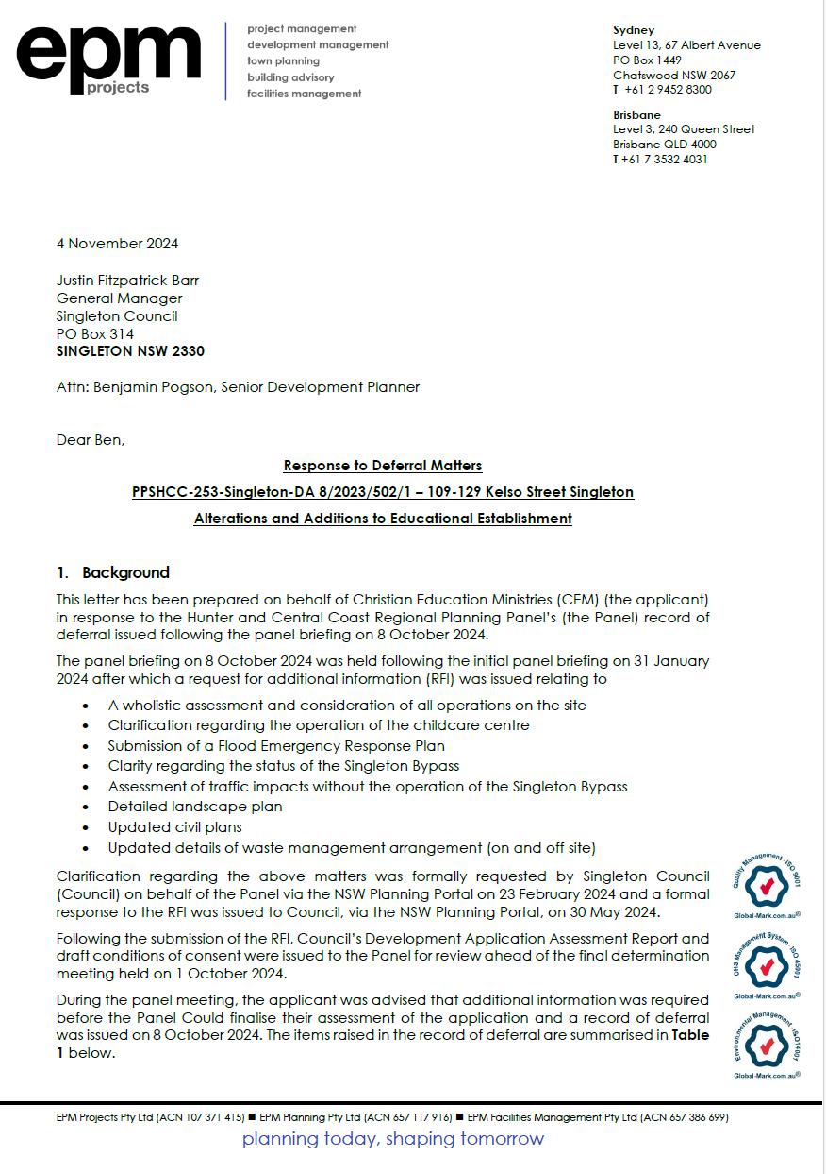

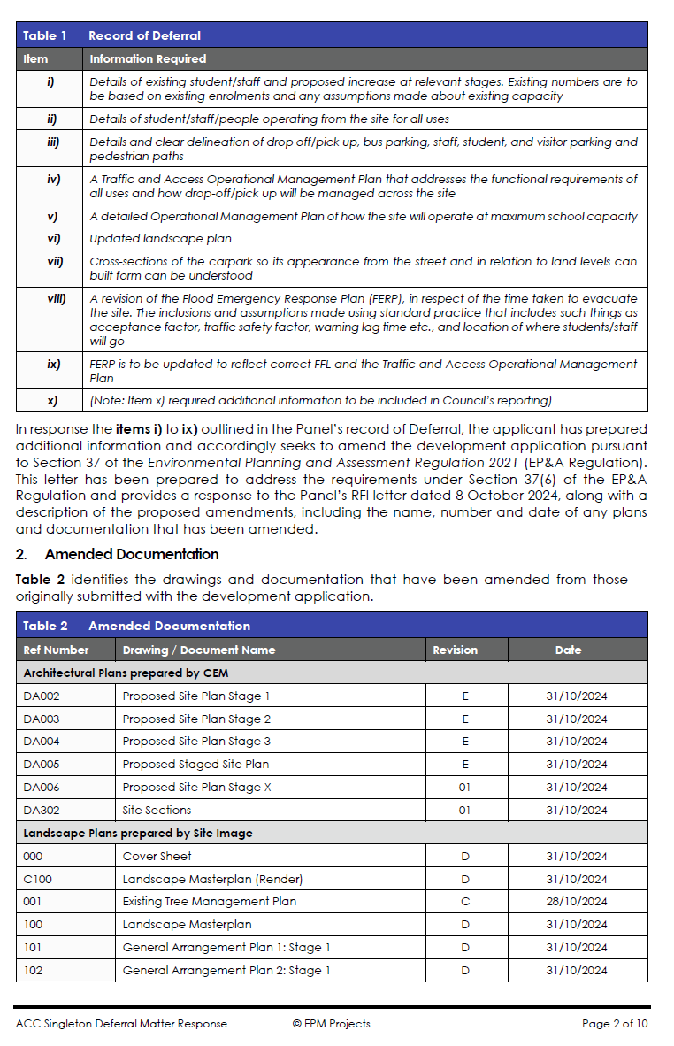

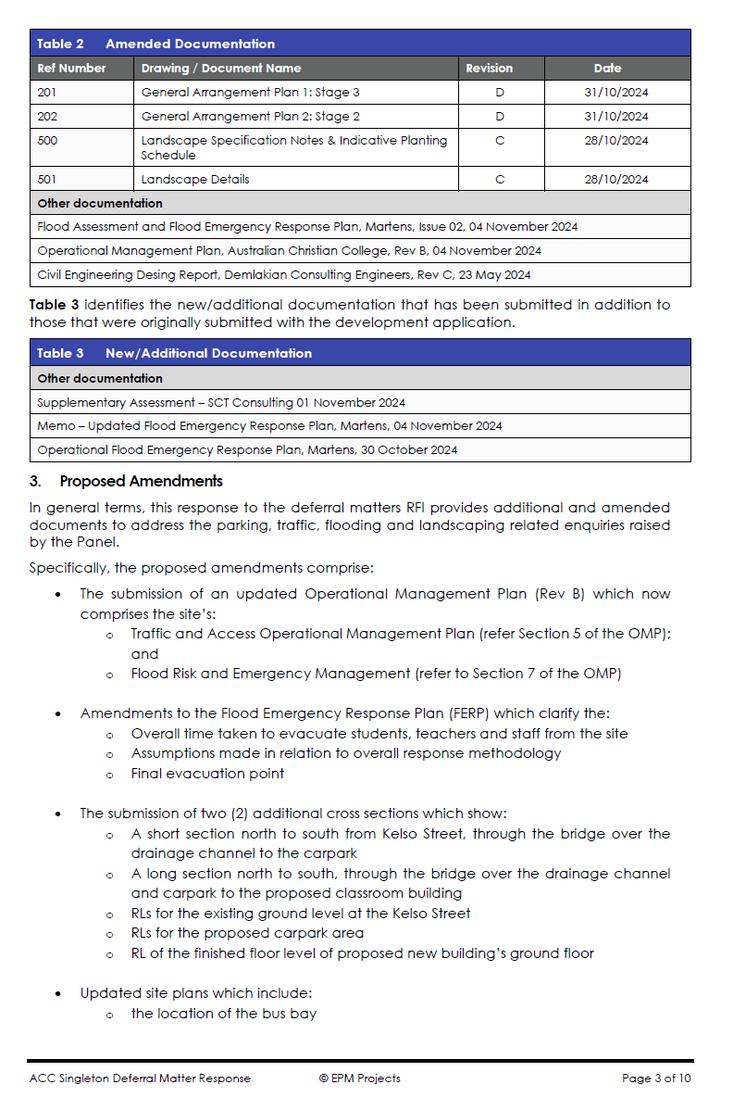

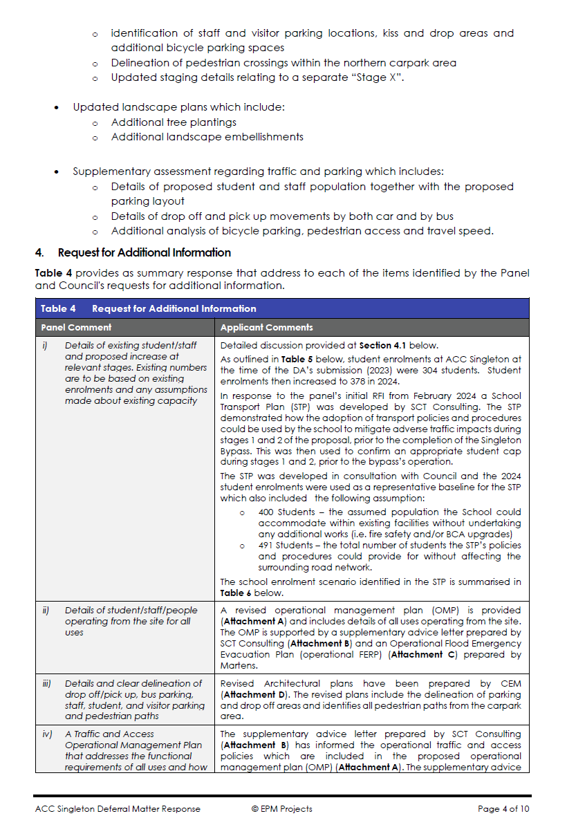

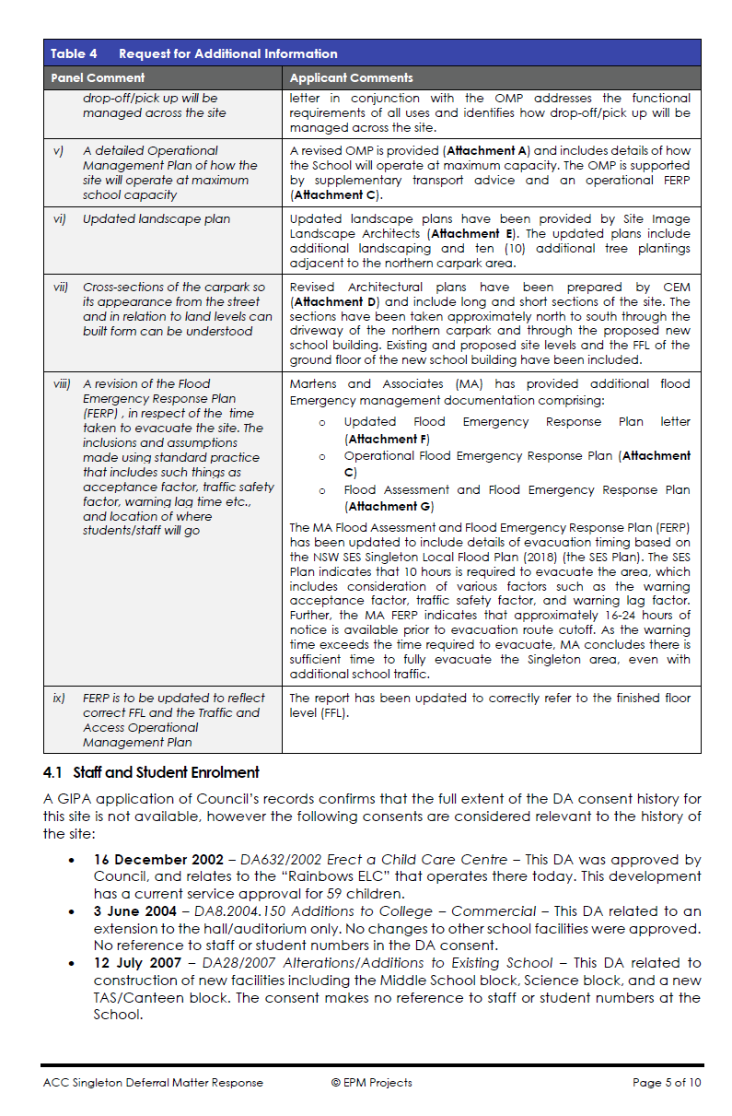

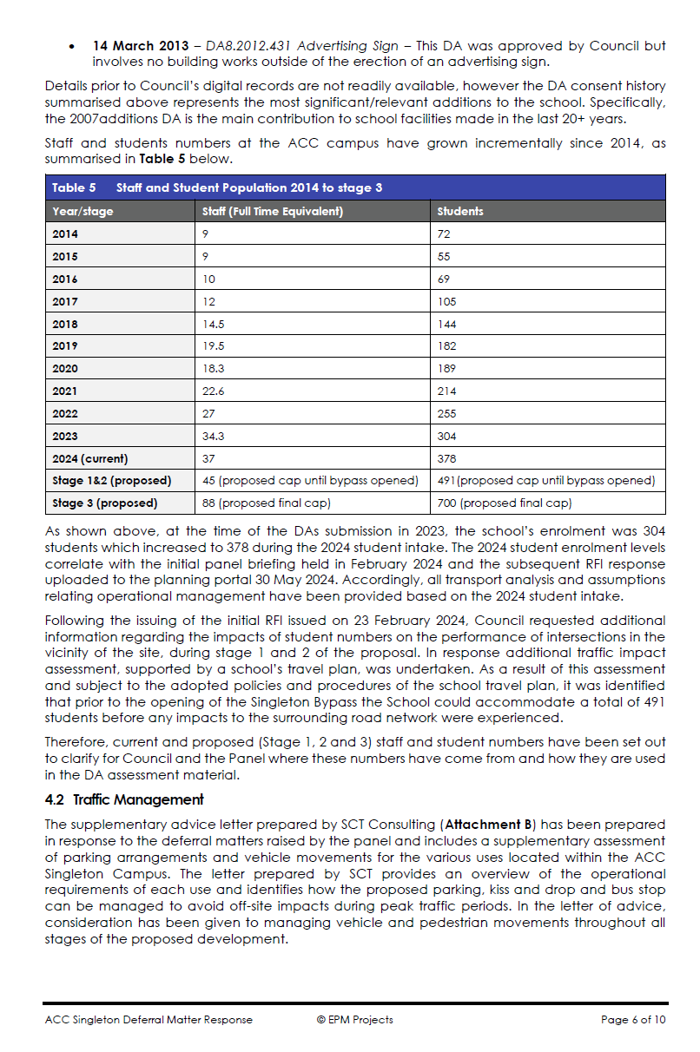

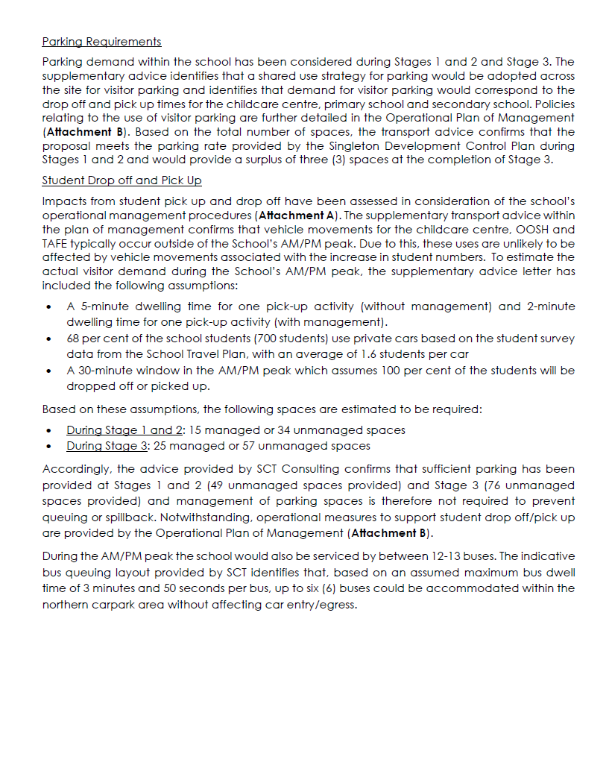

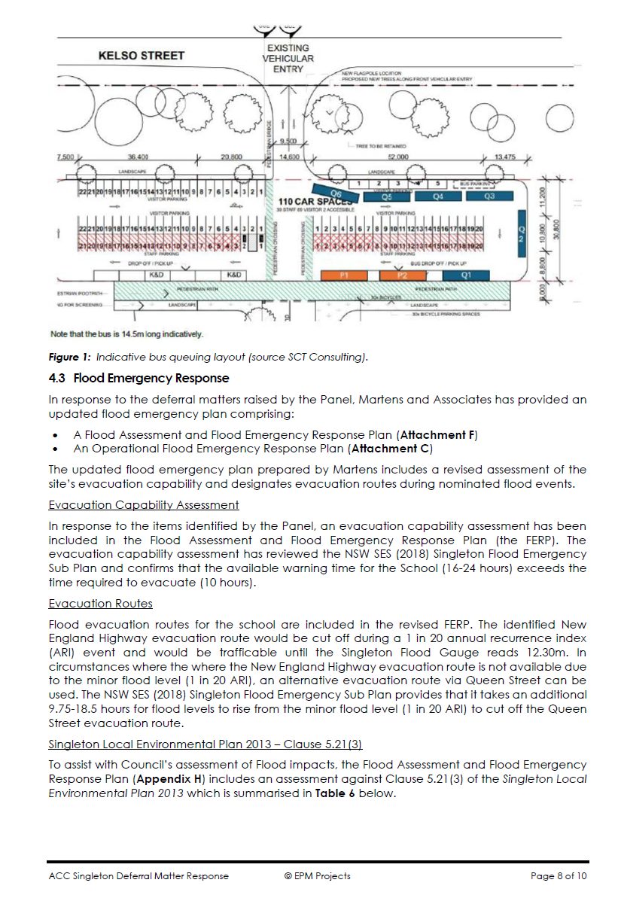

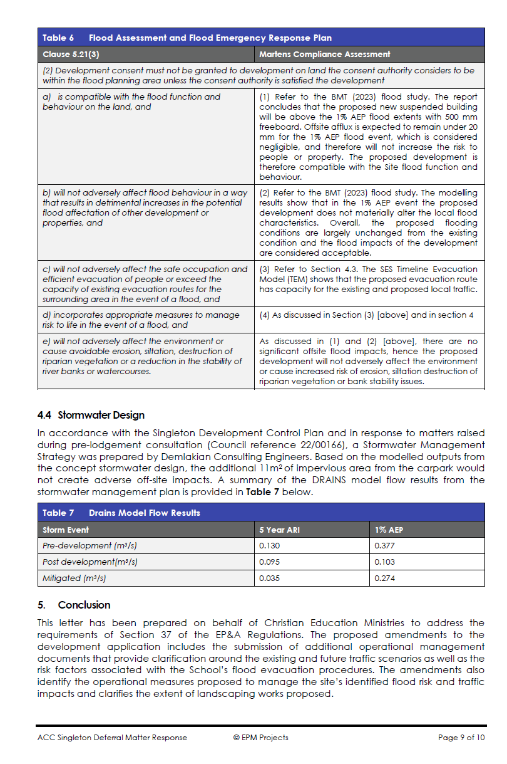

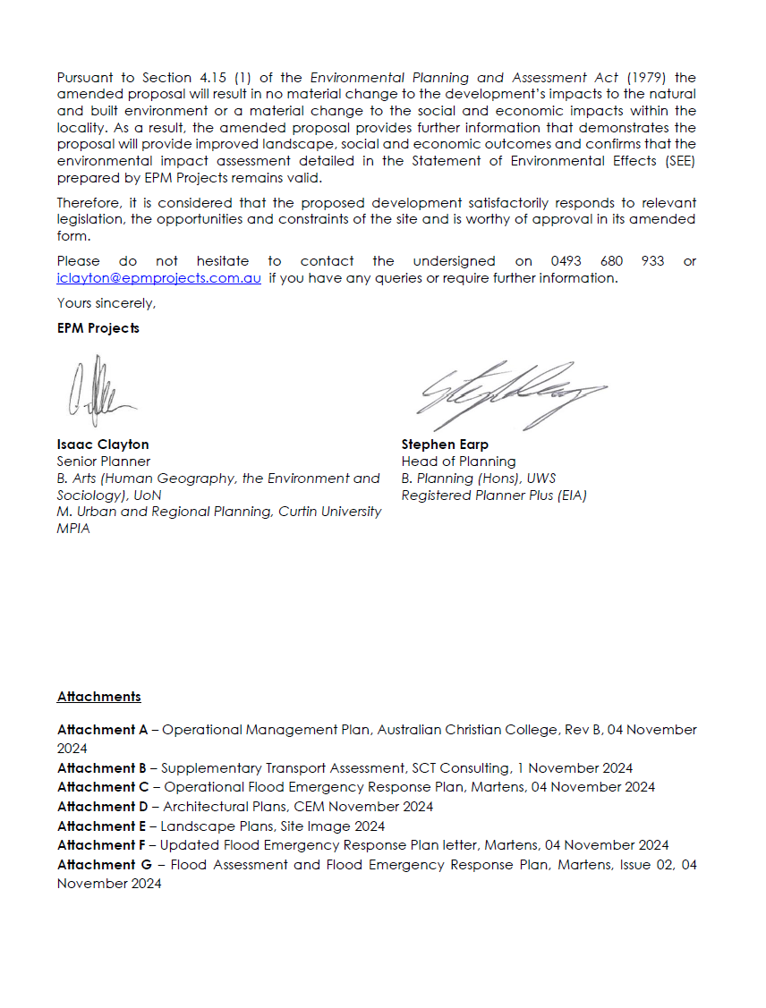

The application was re-referred to the Development Engineer and Traffic Engineer for comment and found satisfactory by the development engineer but not the traffic engineer.

The Traffic Engineer requested further information including addressing the:
- Shortfall in parking and use of shared parking strategy still not justified sufficiently according to DCP Clause 2.27 (subclause 5)
- Inconsistencies between Operation Plan of Management and the Traffic Impact Assessment
- Clashing between queuing buses and passenger vehicles utilising carpark
- detail of pedestrian paths and its interaction with vehicle manoeuvres.

(24/78846, 24/78850, and 24/78851)

The applicant provided updated information to address these concerns.

The updated Plans, Operational Plan of Management and Traffic Impact Assessment have adequately addressed the traffic engineers concerns

Other items to be addressed
    - A clear summary of the flood affection of the site and the impacts tha the proposal will have, and detailed consideration of Clause 5.21 under the SLEP 2013
This has been addressed in this report under the development engineering referral section and under the Part 5 considerations of the LEP section
    - When the Singleton Bypass was approved?.
- Approved August 2020.
- Work started on the project in September 2024.
- Work hours of opperation are being carried out between 7am and 6pm on Monday to Friday and between 8am and 1pm on Saturday.
- As of November 2024 the current stage is “The work will involve earthwork, asphalting, adjustments to road line marking, temporary drainage installation, geotechnical investigation work, utility works, placement of temporary roadside barriers and concrete.”. this includes night works from mid-November to the end of january 2025 7pm – 5am weeknights.
- See mapped areas of nightworks below.
- 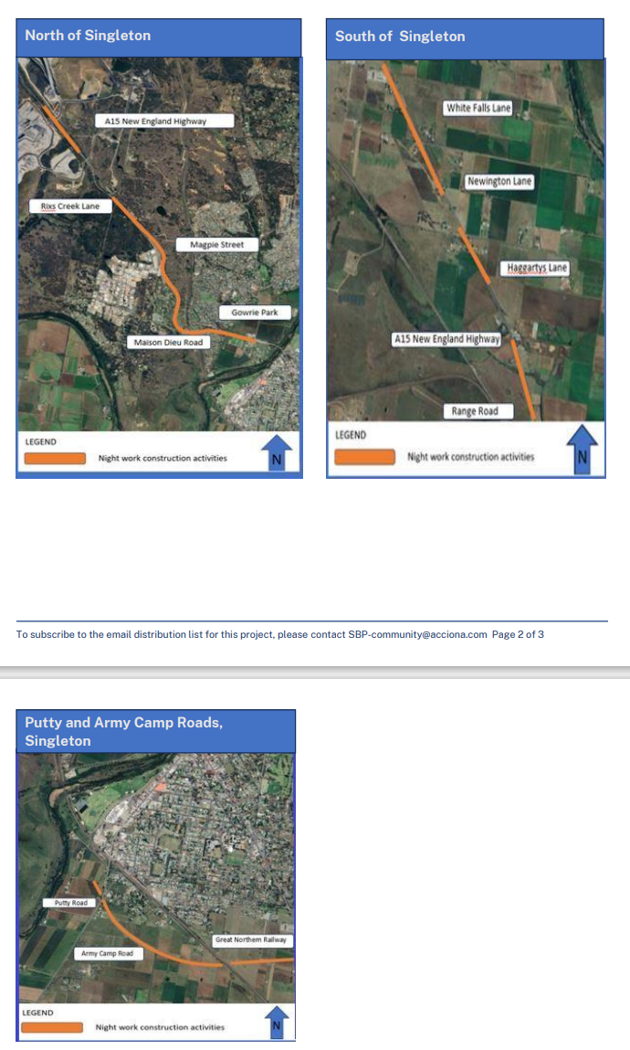
    - Assessment of the Transport and Infrastructire Sepp 2021, Division 3
The State Environmental Planning Policy (Transport and Infrastructure) 2021 section of this report has been updated to reflect these changes.
    - Detailes of Car parking and bicycle parking requirements under Councils DCP
The applicant has addressed this requirement in the “Response to Council RFI dated 21 November” as the DCP allows for a shortfall under Clause 2.27 (5). This is also mentioned in the traffic engneers comments and DCP assessment of this report.
    - What previous consent said about student number
Under section 4 of this report (Site History) there are details about student numbers. There are no records which make reference to approved numbers and many records cannot be located.
    - Assessment of amended documents
Council staff have reviewed the amended documents. These have been found satisfactory. This report and Council referrals have been updated to reflect this new information.
    - Review of conditions to reflect limits and staging.
Reviewed. Amended to reflect staging, including demolition.

State Environmental Planning Policy (Resilience and Hazards) 2021
The aim of the policy is to promote the remediation of contaminated land for the purpose of reducing the risk of harm to human health or any other aspect of the environment. Clause 4.6 of State Environmental Planning Policy is relevant to the assessment of this Development Application.

Clause 4.6 requires that consent not be granted until Council has considered whether the land is contaminated. If the land is contaminated, the Council needs to be satisfied that the land is suitable in its contaminated state (or will be suitable, after remediation) for the purpose for which the development is proposed to be carried out.

The subject site has historically been used for an Education Establishment. As there is no historical evidence of the site being previously used for a purpose which would result in the land being contaminated, further testing of the site in respect of contamination is not warranted in this instance.

State Environmental Planning Policy (Transport and Infrastructure) 2021

Under Clause 3.58, the application was referred to TfNSW. The items raised were considered and addressed by the applicant. See initial response by applicant under the Planning Systems SEPP section.

The applicant provided an updated traffic assessment and School Traffic Plan, which has been assessed and satisfied Councils Traffic Engineers.

Clause 3.36 (3) permits the school, provided it is within the boundaries of an existing or approved school. This development is, therefore is permitted with consent.via subclause 6 and requires assessment of the design quality of the development when evaluated in accordance with the design quality principles set out in Schedule 8 of the SEPP.

Design Quality Principles - Schedule 8
Principle 1. Context Built Form and Landscape
The building was designed to respond to and enhance the positive qualities of its setting and
landscape. The location of the building was determined by site conditions, to minimise flood impact and contribute to the streetscape. Aligned with the entry of the site, the building will define the point of entry for the school.

The Landscape was integrated into the design of the building through sightlines, visually connecting spaces to enhance on-site amenity.

Complies

Principle 2- Sustainable Efficient and Durable
The new school building is designed to minimise the consumption of energy- using window shading, canopy and large eaves, water efficient timed taps.

The reinforced concrete column-slab frame system allows the layout to be adaptable, enabling it to evolve over time to meet future requirements.

Complies

Principle 3 - Accessible and inclusive
The building provides good wayfinding and welcoming, accessible and inclusive to people with differing needs and capabilities, provided by the simple, logical and strategically planned layout.

The new buildings will be accessible to people with disabilities through the provision of a ramp and walkways and a lift connecting all two (2) levels across the site.

The ramp providing access to the building also connects the other school buildings and provides equal access to all students from the existing buildings to the new building.

Complies

Principle 4 - Health and Safety
The building optimises health, safety and security within its boundaries and the surrounding public domain while balancing the need to create a welcoming and accessible environment.

Large internal windows between the General Learning Areas and the atrium provide transparency and enable passive surveillance throughout the building. Security cameras will be installed throughout the building for security.

Opportunity for bullying behaviour has been minimised with careful planning eliminating potential hidden “nooks” and dark “spots” where bullying is more likely to take place.

Further it is adequately designed in accordance with Singleton LEP Clause 5.21

Complies

Principle 5 - Amenity
The proposed building aims to provide pleasant and engaging spaces that are accessible for a wide range of educational, informal and school community activities, while also considering the amenities.

The new general learning areas and Library will be air conditioned In accordance with the recent SINSW DG 55 directive. Administration will also be air conditioned.

All general learning areas and occupied spaces will have natural light in accordance with the Building Code of Australia.

Adequate eaves overhang, awnings and Integrated sun-hoods/light shelves will provide the required solar protection and glare control for the north faces of the buildings.

Site disturbance is minimised by providing an acoustic barrier on the western boundary while the new building is located away from adjoining residents.

Complies

Principle 6 - Whole of life flexible and Adaptive
The building is proposed to be constructed with a reinforced concrete frame, with steel framed external wall and roof construction.

All Internal walls Including bock-up walls to the external building fabric would be plasterboard or sliding aluminium framed doors which can be readily re-configured or removed to suit changing pedagogy.

Facade and building envelope materials are pre-finished for longevity and low maintenance.
During the design, we considered future needs of the whole life cycle approach underpinned by the site wide strategic and spatial planning. The large, free spaces, provide ease of adaptation and maximise multi use facilities. The high environmental performance is the result of the above.

Complies

Principle 7 - Aesthetics
During the design we aimed for the school building and its landscape setting to be aesthetically
pleasing by achieving a built form that has good proportions and a balanced composition of elements.

We responded to positive elements from the site and surrounding neighbourhoods, such as the
character of the site and the adjoining existing buildings with a consistent design carried over and externally and internally, aiming for the complex to have a positive impact on the quality and character of the neighbourhood.

The built form responds to the existing and desired future context, particularly, positive elements from the site and surrounding neighbourhood, and have a positive impact on the quality and sense of identity of the neighbourhood.

The building is positioned in alignment with the site entry and the carpark, directing the public entering the site to the main admin office.

A two storey high entry provides a welcoming volume and good transparency into the heart of the school. The east and west side facades are constructed of lightweight framed walls with prefinished wall panels. The roof will be sheeted with metal deck material wrapping to the eastern facade to create a “homely” feel.

Toilet and service rooms are conveniently located in a central location and accessed from gathering areas. Toilets are mechanically ventilated and will utilise epoxy grout to the tiling to ameliorate smells.
We consider that the design quality principles contained In the Education SEPP can be readily
developed and amplified in greater detail as the project progresses through the Detailed Design phase.

Complies

Division 3
The Panel also requested Divison 3 be considered. Division 3 relates to the “additional uses of State land” as the proposal does not propose to use State land and is therefore not relevant to this proposal

State Environmental Planning Policy (Sustainable Buildings) 2022

The proposed development is not subject to this policy as the development wholly within RU1 zoned Clause 3.1 (2)(b)(i).

Singleton Local Environmental Plan 2013
The Singleton Local Environmental Plan 2013 (SLEP 2013) applies in this instance.
Zoning
The subject site is zoned PART RU1 Primary Production / PART SP2 Infrastructure under the provisions of SLEP 2013. The proposed development consists of an Educational Establishment and is not permissible with consent in the PART RU1 Primary Production

State Environmental Planning Policy (Transport and Infrastructure) 2021

Clause 3.36 (3) permits the school provided it is within the boundaries of an existing or approved school. This development is, therefore is permitted with consent.

Clause 3.6 states that any inconsistencies in an environmental Planning Instrument, that the State Environmental Planning Policy (Transport and Infrastructure) 2021 prevails. Therefore the proposed development is permissable.

Part 1 Preliminary

Clause 1.9A Suspension of covenants

In accordance with the provision of this clause, any agreement, covenant or other similar instrument that restricts the carrying out of that development does not apply to the extent necessary to serve that purpose. The requirements of this clause do not apply in the following circumstances:

- to a covenant imposed by the Council or that the Council requires to be imposed, or
- to any prescribed instrument within the meaning of section 183A of the Crown Lands Act 1989, or
- to any conservation agreement within the meaning of the National Parks and Wildlife Act 1974, or
- to any Trust agreement within the meaning of the Nature Conservation Trust Act 2001, or
- to any property vegetation plan within the meaning of the Native Vegetation Act 2003, or
- to any biobanking agreement within the meaning of Part 7A of the Threatened Species Conservation Act 1995, or
- to any planning agreement within the meaning of Division 6 of Part 4 of the Act.

Further, this clause does not affect the interests of a public authority.

Part 2 Permitted or prohibited development

Clause 2.7 Demolition requires consent

The application seeks consent to for minor demolition works to facilitate the new building and car parking, including:
• Removal of twenty (20) planted species trees comprising:
• Demolition of existing on-site carparking, internal driveway and vehicle access points
• Demolition of existing administrative building
• Minor cut and fill for site levelling

Demolition shall be undertaken in accordance with the relevant Australian Standards.

Part 5 Miscellaneous provisions

Clause 5.10 Heritage Conservation

The subject land is identified on the Heritage Map as containing the heritage item known as I118 “Ardersier”, 48 Maitland Rd, I120 – “Bebeah”, New England Highway, and I129 – Townhead Estate, 5 Townhead Crescent.

A Heritage Impact Statement has been prepared and referred to Councils Heritage Officer.

Council’s Consultant Heritage Advisor has reviewed the proposed development and does not raise any objection.

“The proposal is only considered for its potential impact to Local Heritage Items, which the Heritage Impact Assessment has assessed at nil. Importantly, there will be no physical impacts upon the three heritage items nearby, and there are no detrimental visual impacts on the heritage items. There are no heritage constraints relating to this project therefore.”

Accordingly, the proposed development is consistent with the requirements of clause 5.10.

Clause 5.21 Flood Planning

Singleton Council’s Development Engineer has thoroughly reviewed the proposal and confirmed that the development complies with the flood-related provisions of Clause 5.21 of the Singleton Local Environmental Plan (LEP). The review acknowledges that the proposed design and mitigation measures ensure the development is compatible with the flood characteristics of the site, minimises risk to life and property, and does not result in adverse environmental or economic impacts.

Below is a detailed assessment of compliance with each section of Clause 5.21:

Clause 5.21(2)(a): Compatibility with Flood Function and Behaviour

- The Flood Impact Assessment (BMT, 2023) confirms that the proposed new building’s finished floor level (FFL) is 0.68 metres above the 1% AEP flood level, ensuring resilience to significant flood events. The first floor FFL is positioned 1.15 metres above the probable maximum flood (PMF) level, entirely removing it from flood risk during extreme events.
- Flood behavior modeling shows slow-moving waters on the site (<1 m/s), with negligible offsite afflux (less than 20 mm in the 1% AEP flood), ensuring that the development is compatible with flood function and does not disrupt existing flow patterns.

Clause 5.21(2)(b): No Adverse Effect on Flood Behaviour for Other Properties

- Modeling demonstrates that the development will not exacerbate flood risks for neighbouring properties. The predicted afflux of <20 mm during the 1% AEP event is considered negligible under industry standards, confirming no material increase in flood risk to adjacent sites.
- Mitigation measures, including improved site grading and drainage systems, reduce potential adverse impacts.

Clause 5.21(2)(c): Safe Occupation, Efficient Evacuation, and Evacuation Route Capacity

- The Flood Emergency Response Plan (FERP) outlines detailed evacuation procedures, which leverage sufficient warning times (16–24 hours) from predictive flood monitoring systems. These procedures include two identified evacuation routes, with capacity for all occupants, even in expanded development stages.
- The evacuation timeline accounts for increased site populations and additional traffic, confirming that evacuation routes (via the New England Highway and Queen Street) remain viable and efficient.

Clause 5.21(2)(d): Measures to Manage Risk to Life During a Flood

- Key measures include flood awareness training, communication protocols, and signage to enhance occupant safety. Real-time monitoring systems (e.g., BoM and WaterNSW alerts) support proactive site closures and preemptive evacuations in response to anticipated flood events.
- Flood-safe areas and elevated design features ensure that, even if occupants remain onsite during unexpected events, the risk to life is minimised.

Clause 5.21(2)(e): Environmental and Stability Impacts

- The development incorporates design measures to ensure it does not cause avoidable erosion, siltation, or harm to riparian vegetation. Drainage improvements are included to stabilise water flows and maintain bank integrity, aligned with recommendations in the Singleton Flood Risk Management Study.

Clause 5.21(3): Additional Considerations

Clause 5.21(3)(a): Impact of Climate Change on Flood Behaviour

- The flood assessment used the 0.5% AEP flood scenario as a proxy for climate change impacts, demonstrating that the development would maintain acceptable risk levels even under increased flood scenarios.

Clause 5.21(3)(b): Design and Scale of Proposed Buildings

- The proposed buildings are appropriately scaled and sited to remain unaffected by the 1% AEP flood level, with adequate freeboard for all habitable spaces. The design ensures minimal interference with flood flows while maintaining safe access and egress during emergencies.

Clause 5.21(3)(c): Measures to Minimise Risk to Life and Ensure Safe Evacuation

- The FERP ensures site readiness with annual training, emergency kits, and detailed communication protocols. Evacuation drills and awareness training for staff and occupants further reinforce preparedness.

Clause 5.21(3)(d): Potential for Modifying or Relocating Buildings

- The development has been sited and designed to ensure its compatibility with floodplain dynamics. Since the proposed buildings are elevated and pose no offsite impacts, there will be no foreseeable need for relocation or modification, even under extreme flooding conditions.

Conclusion

The proposed development incorporates comprehensive flood mitigation and management measures, ensuring full compliance with Clause 5.21 of the Singleton LEP. It addresses flood risks to life, property, and the environment while supporting safe and efficient evacuation, demonstrating compatibility with the flood function and behaviour of the site.

Part 7 Additional local provisions

Clause 7.1 Earthworks

Clause 7.1 seeks to ensure that any earthworks do not result in an adverse impact on the environment, neighbouring properties or heritage items. Earthworks proposed are considered to be minor/reasonable and will not result in any detrimental impact upon the surrounding environment, quality of material to be removed or brought to the site, amenity of adjoining neighbours, the drinking water catchment, environmentally sensitive areas or relics.

Clause 7.10 Essential Services

Suitable arrangements have been made for the site to be connected to water supply, electricity, sewage disposal, stormwater drainage and vehicular access

(a)(ii) the provisions of any proposed environmental planning instrument (EPI)

There are no draft EPI’s applicable to the subject site or proposed development.

(a)(iii) any development control plan

The Singleton Development Control Plan (DCP) 2014 applies to the land with the following chapters of particular relevance to the proposal:

Part 1: Preliminary

Chapter 1.13 Alternative solutions

This section of the DCP provides for flexibility in the application of standards prescribed by the DCP in order to achieve better outcomes. Any variation to the requirements of this plan are required to demonstrate that:

- Compliance is unreasonable or unnecessary,
- The application can be justified on planning merit, and/or
- The proposed development meets the objectives of the standard.

The application proposes to vary chapter:

- 2.11 – Setbacks

In support of the variation, the applicant has submitted a written request in accordance with this section. A discussion of the proposed variation is provided within the relevant section below. Where the assessment provides that the development is satisfactory, it is considered that the variation is not unreasonable and will not cause any hardship.

Chapter 1.14 Minimum information for development applications

Suitable information has been submitted with the application in accordance with Schedule 1 of the Environmental Planning and Assessment Regulation, 2000 and Schedule 5 of the DCP.

Part 2: Principal Design

Chapter 2.4 Stormwater drainage system

The objectives of this section aim to ensure that stormwater can be disposed in a suitable manner without casing nuisance to adjoining properties or over load the existing stormwater system. Suitable measures have been proposed to control stormwater leaving the site in accordance with the provisions in accordance with Council Engineering Design Specifications. Stormwater quality meets the requirements of the DCP.

The application is consistent with the provisions of section 2.4.

Chapter 2.9 Maximum building height

The objective of this clause is to ensure building heights are appropriate having regard to the character of the area, whilst minimising potential impacts associated with building height.

The subject land is identified on the map as having a building height of 11m. Development proposed by this application proposes a height of 9.8m, consistent with the requirement of the DCP. The proposed development is consistent with the character of the area, is sympathetic to the aesthetics of the locality, will not result in an overlooking or overshadowing of adjoining properties and will not impact upon any heritage values.

The application is consistent with the provisions of section 2.9.

Chapter 2.10 Building line for land in certain rural, residential, business and industrial zones

The objectives of this section are to maintain a consistent streetscape, encourage landscaping within the front setback and minimise road noise by requiring suitable setbacks.

The subject land is zoned RU1, as such the provisions of this section apply.

In accordance with the DCP, the following building line setback is required:
- 40m for land zoned RU4.

All walls with a height of 10m or greater are setback at least 3m behind the building line.

The application is consistent with the provisions of section 2.10.

Chapter 2.11 Side and rear setbacks for buildings in certain rural and environmental living zones

The objectives of this section aim to maintain privacy and amenity and minimise land use conflict.

The subject land is zoned RU1, as such the provisions of this section apply.

In accordance with the DCP, a minimum side and rear setback of 10m is required.

As a result of the Phase 2 built form, the proposal would include a minor encroachment into the required 10 metre rear setback distance. The encroachment would be caused by the landing and stair of the building’s rear ground floor entry.

However, as the rear of the site backs directly onto Waddells Lane and would not affect the amenity of adjoining occupiers, the proposal would be consistent with the objectives of the control despite the numerical non compliance as:

- Privacy of adjoining neighbours would not be affected
- The siting of the building still maintains an appropriate degree of separation from the property boundary

In this instance, the proposed variation to Council’s requirement(s) is considered reasonable.

Chapter 2.16 Environmental outcomes

The objectives of this section aim to avoid impact, maintain biodiversity, minimise land degradation and encourage environmentally responsible design.

The proposed development is suitably located and designed so as to avoid impacts on biodiversity, prevent land degradation and salinity, maintain water quality and minimise clearing.

The application is consistent with the provisions of section 2.16.

Chapter 2.18 Landscaping

The objectives of this section aim to ensure high quality landscaping, improve the appearance of development, ensure landscaping is safe and appropriate and ensure good urban design outcomes.

Development proposed by this application involves construction of a car park and erection of a building visible from a public road, as such the provisions of this section apply.

Landscaping proposed as part of this application is satisfactory; enhancing the streetscape appearance of the development, is an appropriate scale, is appropriate to the development type, is consistent with landscaping in the area and will not cause harm, increase the bush fire risk or restrict sight lines.

The application is consistent with the provisions of section 2.18.

Chapter 2.19 Heritage conservation

The objectives of this section aim to conserve environmental heritage, prevent deterioration of items and minimise the impact of development heritage significant/conservation areas.

As the development is located within the vicinity of a heritage item, the provisions of this section apply.

The application was referred to Council’s Consultant Heritage Advisor who has confirmed the development will not unreasonably impact upon the heritage significance of the item or conservation area. A statement of heritage impact was submitted as part of the application. The heritage impact assessment is considered by Council’s Consultant Heritage Advisor to be satisfactory.

Chapter 2.21 Earthworks and retaining

The objectives of this section are to avoid excessive cut/fill and to encourage design to suit topography.

Cut/fill proposed as part of this application will not impact upon the structural integrity of any adjoining buildings.

The application is consistent with the provisions of section 2.21.

Chapter 2.23 Building appearance

The objectives of this section are to ensure good urban design outcomes, protect the visual amenity of the streetscape, encourage design to build to the site and ensuring development does not detract from the visual amenity of the area.

Development proposed by this application does not detract from the visual amenity of the streetscape, is of a suitable bulk and scale and the building has been integrated into the site having regard to the topography and site features. Blank walls are avoided through the use of windows and/or material variation and appropriate articulation of the wall surface. Building materials and colours are compatible with the character of the area and where relevant reflect heritage values.

The application is consistent with the provisions of section 2.23.

Chapter 2.25 Accessible design

The objective of this section is to ensure suitable arrangements are made for people with a disability.

As the proposed development is accessible to the public, the provisions of this section apply.

The application was referred to Council’s Building Surveyor for comment, who has confirmed that development is satisfactory having regard to the requirements of the Disability Discrimination Act, 1992 and the Disability (Access to Premises – Building) Standards 2010.

The application is consistent with the provisions of section 2.25.

Chapter 2.26 Driveway access

The objective of this section is to ensure driveways are suitably located and have an appropriate surface treatment.

Access to the site will remain from Kelso Street to the main car park. The secondary access will also remain from Waddells Lane to a separate smaller car park.

The applicant is proposing to upgrade both accesses as part of stage 1 of the works with the Kelso Street access increased to 9.5m in width. The turning swept paths provided show that the access road will be adequate for buses with a wheelbase length of 8.20m.

Council’s Development Engineer has reviewed the application, confirming the proposed driveway is consistent with the requirement of this section.

Chapter 2.27 Minimum number of car parking spaces

The Singleton DCP specifies the following parking requirements:

- Childcare Centre - 1 space per staff member + 1 space per 4 enrolled children.
Development (no change to existing) = 55 students and 15 staff (14 and 15 spaces)

- School - 0.5 space per staff member + 1 space per 10 students
Development Stage 2 - 700 students and 88 staff = 70 + 44 spaces

Total required spaces = 143 spaces

The TIA states "A total of 82 spaces and 130 spaces are provided in the master plan for Stage 1 and Stage 2, respectively, which satisfies the DCP requirement."

The parking spaces provided is a shortfall of 13 spaces based on the requirements of the DCP.

As per the previous referral, it is agreed that 0.75 parks per student (525 bicycle spaces) is excessive. Unsure how a reasonable amount would be determined. Traffic impact assessment states current active transport share of 3% (walking and cycling) resulting in a need for 20 bicycle parking spaces.

Possible method for determining need:
TfNSW Active Transport Strategy states that 15% and 14% of primary and secondary school students travel to school via active transport. Assume even split between cycles and other modes (walking, scooter etc) gives a need of 7.25% or 50 bicycle parking spaces for 700 students.

Council’s Traffic Engineer has reviewed the application, confirming the proposed parking is consistent with the requirement of this section.

Chapter 2.28 Design of car parking areas, loading docks and vehicle manoeuvring areas

The objectives of this section are to ensuring car parking areas, loading docks and manoeuvring areas are suitably designed and to minimise the visual impact of hard stand areas.
Based on vehicle tracking paths provided in engineering plans, when more than 2 school buses are on site access and egress on western side of carpark will be affected. There is potential for buses queuing to block passenger vehicles from egress which could have a flow on effect of backing up both buses and passenger vehicles onto Kelso Street. The applicant addressed points raised above through amended Operational Plan of Management and Masterplan. This includes changing the location of the staff parking to ensure the following;

- Any bus entering the carpark must manoeuvre and pull over on the left-hand side of the driveway carriageway area, such as to enable all other carpark users to be able to pass on the right-hand side of the driveway carriageway area (i.e. the inside track) to maintain vehicle movements and prevent queuing.

- Each bus must queue in the positions identified by SCT Consulting (as shown in Figure 2 below), and at the point any bus is queued in position Q5, that driver must radio all school buses to confirm that there is only one (1) position remaining and any other bus driving toward the site must continue moving in the local street network and not stop or queue on Kelso Street or beyond position Q6.

- Any reversing movements required to move into positions Q2, Q3, Q4, Q5 or Q6 must be carried out only with staff supervision, so that manoeuvres do not impact traffic flows moving into the site from Kelso Street. Any vehicles queued behind a bus moving into one of these positions will need to be managed so that the bus reversing movement can occur without blocking traffic movements.

The above measures will ensure that there is not conflict between bus and vehicle movement such that queuing will extend out of the site and onto Kelso Street

The application was referred to Council’s Development Engineer for comment all issues have been resolved.

The application is consistent with the provisions of section 2.28.

Chapter 2.29 Waste storage and collection areas

This section aims to ensure that suitable waste storage and collection areas are provided on site in convenient locations in order toreduce illegal dumping, maintain hygiene standards and reduce potential impacts on amenity associated with the collection and storage of waste.

Appropriate provisions have been made for the storage and collection of waste in accordance with the DCP. The collection/storage area is suitably located, is sheltered from the weather, is able to be cleaned and is located in an area which is not visible from the street.

The application is consistent with the provisions of section 2.29.

Chapter 2.34 Views and visual impact

The objectives of this section aims to achieve good urban design outcomes, minimise impact on the local amenity and ensure development is appropriate having regard to development in the local area.

Development proposed by this application will not have any significant impact on the visual quality of the locality, landscape or streetscape. Having regard to the matter listed in section 5, the application meets the requirements of section 2.34.

Part 4: Miscellaneous provisions

Chapter 4.1 Operational details

The objective of this section is to ensure that land uses are suitably managed.

Operational details associated with the development include the following:

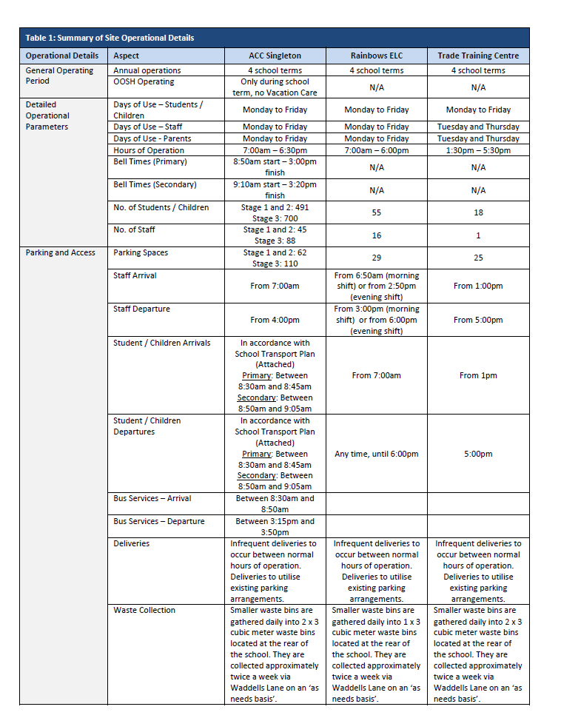

An Operational Plan of Management was submitted with the Development Application and is satisfactory, having regard the provisions within section 4.1.

Chapter 4.3 Site planning

The objectives of this section are to ensure that development is sited having regard to the characteristics of the land, adjoining development, site constraints and infrastructure.

The subject land is considered suitable to accommodate the proposed development. Development proposed by this application has been suitably sited having regard to constraints over the land, topography, potential impacts on adjoining development, bulk, scale, pedestrian networks, streetscape and skyline.

The application is consistent with the provisions of section 4.3.

(a)(iiia) - any planning agreement that has been entered into under section 7.4, or any draft planning agreement that a developer has offered to enter into under section 7.4

There is no draft planning agreement/planning agreement that the developer has offered or enter into under section 7.4 of the Act that relates to the subject land or proposed development.

(a)(iv) any matters prescribed by the regulations

Part 11 of the (Environmental Planning and Assessment (Development Certification and Fire Safety) Regulation 2021 applies to the proposal.
The proposal fulfils the fire safety and structural adequacy requirements of the regulations and is therefore considered appropriate. In accordance with the requirements of the regulation, a condition of consent is included requiring the submission of annual fire safety statement from the applicant.

(b) the likely impacts of the development

The proposed development is not expected to result in any significant impacts on the natural and built environment, or have any detrimental social or economic impacts in the locality. There are no additional impacts anticipated outside of those already addressed elsewhere in this report.

(c) the suitability of the site for the development

The site is considered suitable for the type, scale and nature development and is not overly constrained. The development can be integrated into the locality without any significant adverse impacts. The site is therefore considered suitable for the proposed development.

(d) any submissions made in accordance with this Act or the regulations

Public Submissions

The development application and accompanying information were placed on public exhibition for a period of 14 days from 13/11/2023 to 27/11/2023. As a result of the notification process a total of 0 submissions were received.

(e) the public interest

The proposed development is in the public interest.

Section 4.17 Considerations

Having regard to the matters for consideration detailed in Section 4.15 of the Environmental Planning and Assessment Act 1979, there are no additional matters which require further consideration.

Section 7.11 - Contributions
Are contributions required for the provision, extension or augmentation of public amenities and public services? | Yes | No
Are Section 7.11 Contributions payable on the proposed development? | ☐ | ☒
Is a VPA relevant? | ☐ | ☒

Section 4.65 – Existing Use Rights

The proposed development is not prohibited under the SLEP 2013.

- Council Policies / Council Resolutions

There are no Council Policies and/or Council resolutions relevant to the assessment of the application.

- Development Assessment Guidelines

There are no guidelines published by the NSW Planning and Environment that are relevant to the proposed development.

- Land & Environment Court Planning Principles

There are no planning principles required to be considered in the assessment of the development application.

- Recommendation
An assessment of the application has been carried out in accordance with Section 4.15(1) of the Environmental Planning and Assessment Act 1979. The proposed development is considered satisfactory in terms of the matters for consideration under the Act. Accordingly, the development application is approved subject to conditions of consent.

- Delegations

This application has been approved under delegated authority as no objections have been received and the proposal complies with Council’s standards,the undersigned has delegations to determine the application.

Officer: B Pogson

Position: Senior Development Planner

Date: 22/11/2024

